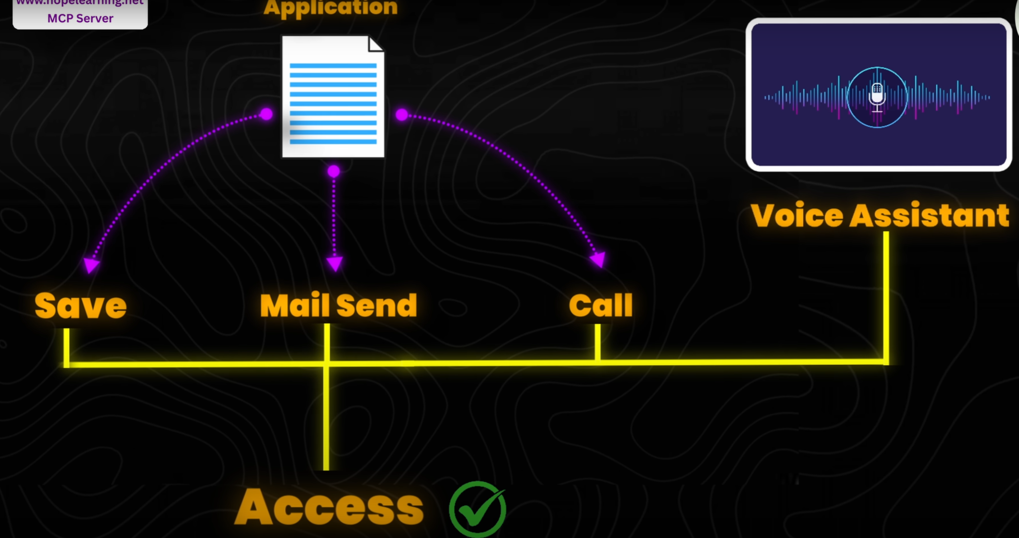  
Still MCP adapter is not introduced in ChatGPT