<https://www.bogotobogo.com/AngularJS/AngularJS_Introduction.php>

* directives, expressions, templates, and data binding.
* Controllers, Modules, Events, DOM, Forms, Input, Validation, Http, and much more.

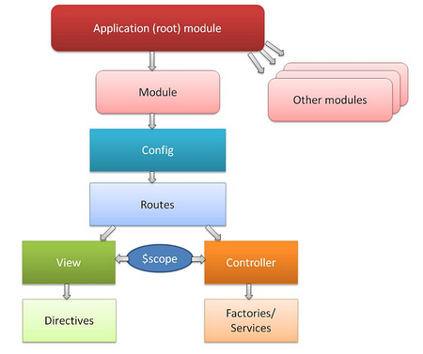

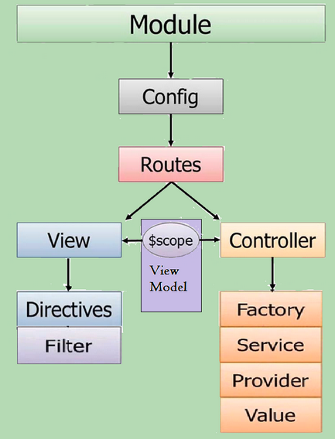

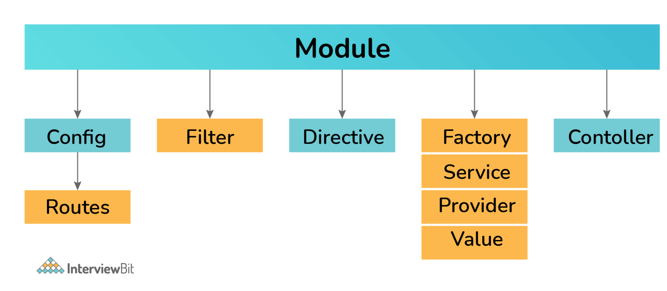

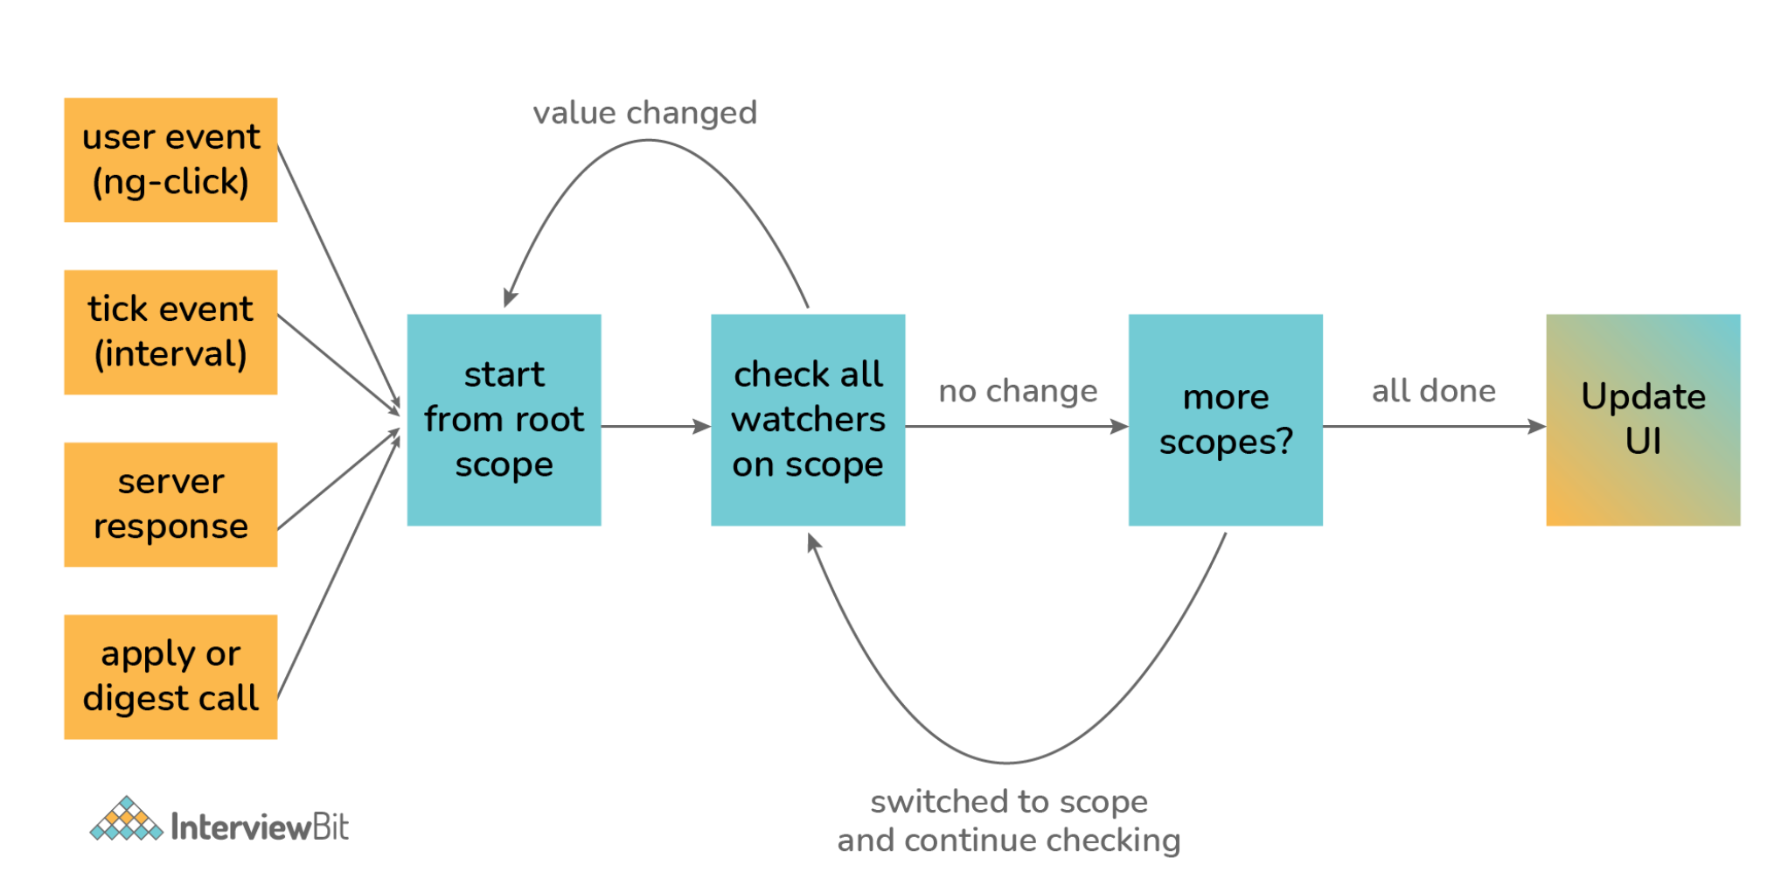

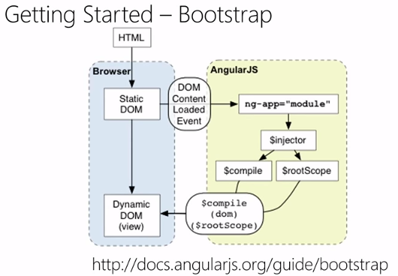

Five commandments of AngularJS

1. HTML is the view!
2. REST APIs should provide Perfect JSON.
3. Communication is one way:  
   Directives->HTML->Controller->Services.
4. The controller DOES NOT manipulate the DOM (use directives).
5. Single-responsibility principle for controllers, services and directives.

<https://www.bogotobogo.com/AngularJS/AngularJS_Dependency_Injection.php>

AngularJS

• [Introduction](https://www.bogotobogo.com/AngularJS/AngularJS_Introduction.php)

• [Directives I - ng-app, ng-model, and ng-bind](https://www.bogotobogo.com/AngularJS/AngularJS_ng-directives.php)

• [Directives II - ng-show, ng-hide, and ng-disabled](https://www.bogotobogo.com/AngularJS/AngularJS_More_Directives_HTML_DOM.php)

• [Directives III - ng-click with toggle()](https://www.bogotobogo.com/AngularJS/AngularJS_More_Directives_ng_click.php)

• [Expressions - numbers, strings, and arrays](https://www.bogotobogo.com/AngularJS/AngularJS_Expressions.php)

• [Binding - ng-app, ng-model, and ng-bind](https://www.bogotobogo.com/AngularJS/AngularJS_Binding.php)

• [Controllers - global controllers, controller method, and external controllers](https://www.bogotobogo.com/AngularJS/AngularJS_Controllers.php)

• [Data Binding and Controllers (Todo App)](https://www.bogotobogo.com/AngularJS/AngularJS_Controller_DataBinding_TodoList_App.php)

• [Todo App with Node](https://www.bogotobogo.com/MEAN-Stack/MEAN-Stack-MongoDB-ExpressJS-AngularJS-NodeJS-ToDoList-App-B.php)

• [$scope - A glue between javascript (controllers) and HTML (the view)](https://www.bogotobogo.com/AngularJS/AngularJS_Scopes.php)

• [Tables and css](https://www.bogotobogo.com/AngularJS/AngularJS_Tables.php)

• [Dependency Injection - http:fetch json & minification](https://www.bogotobogo.com/AngularJS/AngularJS_Dependency_Injection.php)

• [Filters - lower/uppercase, currenty, orderBy, and filter:query with http.get()](https://www.bogotobogo.com/AngularJS/AngularJS_Filters.php)

• [$http - XMLHttpRequest and json file](https://www.bogotobogo.com/AngularJS/AngularJS_HttpRequest_json.php)

• [Module - module file and controller file](https://www.bogotobogo.com/AngularJS/AngularJS_Module.php)

• [Forms](https://www.bogotobogo.com/AngularJS/AngularJS_Forms.php)

• [Routes I - introduction](https://www.bogotobogo.com/AngularJS/AngularJS_Routing.php)

• [Routes II - separate url template files](https://www.bogotobogo.com/AngularJS/AngularJS_Routing_B.php)

• [Routes III - extracting and using parameters from routes](https://www.bogotobogo.com/AngularJS/AngularJS_Routing_C.php)

• [Routes IV - navigation between views using links](https://www.bogotobogo.com/AngularJS/AngularJS_Routing_D.php)

• [Routes V - details page](https://www.bogotobogo.com/AngularJS/AngularJS_Routing_E.php)

• [AngularJS template using ng-view directive : multiple views](https://www.bogotobogo.com/AngularJS/AngularJS_multiviews_ng-app_ngRoute_config_routeProvider-templateUrl_ng-view.php)

• [Nested and multi-views using UI-router, ngRoute vs UI-router](https://www.bogotobogo.com/AngularJS/AngularJS_ui-route-vs-ngRoute-multiple-views-nested-views.php)

• [Creating a new service using factory](https://www.bogotobogo.com/AngularJS/AngularJS_Factory_Services.php)

• [Querying into a service using find()](https://www.bogotobogo.com/AngularJS/AngularJS_Query_into_a_Service.php)

• [angular-seed - the seed for AngularJS apps](https://www.bogotobogo.com/AngularJS/AngularJS_Seed_for_Apps_angular-seed.php)

• [Token (JSON Web Token - JWT) based auth backend with NodeJS](https://www.bogotobogo.com/AngularJS/AngularJS_Token_JSON-Web-Token-JWT_Based_Auth_Backend_NodeJS.php)

• [Token (JSON Web Token - JWT) based auth frontend with AngularJS](https://www.bogotobogo.com/AngularJS/AngularJS_Token_JSON-Web-Token-JWT_Based_Auth_Frontend_AngularJS.php)

• [Twitter Bootstrap](https://www.bogotobogo.com/AngularJS/AngularJS_Twitter_Bootstrap.php)

• [Online resources - List of samples using AngularJS (Already launched sites and projects)](https://www.bogotobogo.com/AngularJS/AngularJS-How-To-Start-Sample-Projects.php)

• [Meteor Angular App with MongoDB (Part I)](https://www.bogotobogo.com/AngularJS/Meteor-AngularJS-ToDo-App-with-MongoDB-1.php)

• [Meteor Angular App with MongoDB (Part II - Angular talks with MongoDB)](https://www.bogotobogo.com/AngularJS/Meteor-AngularJS-ToDo-App-with-MongoDB-2.php)

• [Meteor Angular App with MongoDB (Part III - Facebook / Twitter / Google logins)](https://www.bogotobogo.com/AngularJS/Meteor-AngularJS-with-MongoDB-User-Registration-Social-Auth-Facebook-Twitter-GooglePlus.php)

• [Laravel 5 / Angular Auth using JSON Web Token (JWT) - Prod](https://www.bogotobogo.com/Laravel5/Laravel5_Angular_Auth_using_JSON_Web_Token_JWT_On_Production.php)

• [Scala/Java Play app with Angular](https://www.bogotobogo.com/Java/tutorials/ScalaPlay/ScalaPlayIntroduction.php)