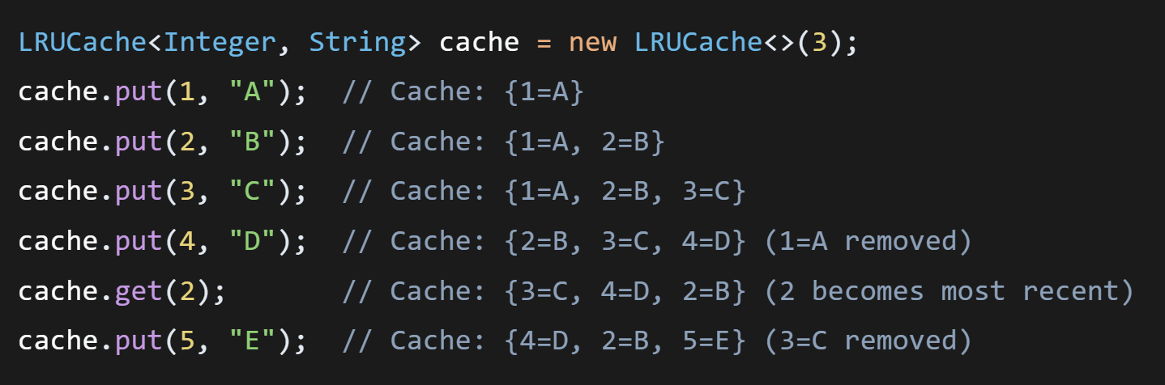
LRUCache<Integer, String> cache = new LRUCache<>(3);
cache.put(1, "A"); // Cache: {1=A}
cache.put(2, "B"); // Cache: {1=A, 2=B}
cache.put(3, "C"); // Cache: {1=A, 2=B, 3=C}
cache.put(4, "D"); // Cache: {2=B, 3=C, 4=D} (1=A removed)
cache.get(2); // Cache: {3=C, 4=D, 2=B} (2 becomes most recent)
cache.put(5, "E"); // Cache: {4=D, 2=B, 5=E} (3=C removed)

