[Cyclic Barrier in Java (youtube.com)](https://www.youtube.com/watch?v=IzEOGpjzAr4&ab_channel=MartOosterveld)

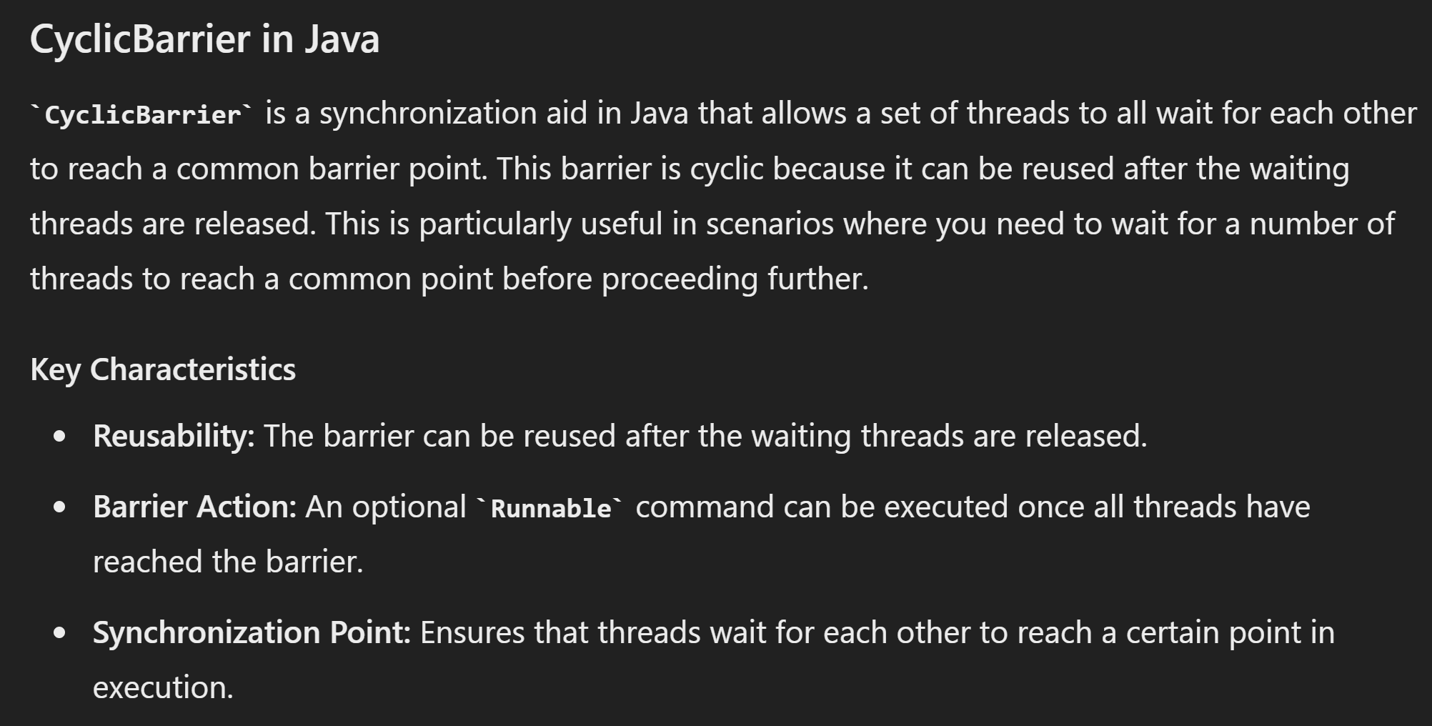

<https://raw.githubusercontent.com/vsaravanan/java22/master/src/main/java/com/saravanjs/java22/console/collection/CyclicBarrierExample.java>

*public class* CyclicBarrierExample {  
  
 *public static void* main(String[] args) {  
 *var* service = Executors.*newFixedThreadPool*(3);  
 *try* {  
 CyclicBarrier c1 = *new* CyclicBarrier(3, () -> System.*out*.println("All cleaning is done, lets turn off the lights, activate alarm and go home!"));  
  
 CyclicBarrierExample cleaner = *new* CyclicBarrierExample();  
 *for* (*int* i = 0; i < 3; i++) {  
 service.submit(() -> cleaner.clean(c1));  
 }  
 } *finally* {  
 service.shutdown();  
 }  
 }  
  
 *private void* clean(CyclicBarrier c1) {  
 *try* {  
 vacuumFloor();  
 Thread.*sleep*(Math.*round*(Math.*random*() * 1000));  
 coffeeBreak();  
 Thread.*sleep*(Math.*round*(Math.*random*() * 1000));  
 mopFloor();  
 Thread.*sleep*(Math.*round*(Math.*random*() * 1000));  
 c1.await();  
 turnOffLights();  
 activateAlarm();  
 } *catch* (InterruptedException | BrokenBarrierException exception) {  
 System.*out*.println(exception.getMessage());  
 }  
 }  
  
 *private void* vacuumFloor() {  
 System.*out*.println("Vacuming the floor...");  
 }  
 *private void* mopFloor() {  
 System.*out*.println("Mopping the floor...");  
 }  
  
 *private void* coffeeBreak() {  
 System.*out*.println("Time for a break!");  
 }  
 *private void* turnOffLights() {  
 System.*out*.println("Turning off the lights...");  
 }  
 *private void* activateAlarm() {  
 System.*out*.println("Activating the alarm...");  
 }  
}

Vacuming the floor...

Vacuming the floor...

Vacuming the floor...

Time for a break!

Mopping the floor...

Time for a break!

Mopping the floor...

Turning off the lights...

Activating the alarm...

Time for a break!

Turning off the lights...

Activating the alarm...

Mopping the floor...

Turning off the lights...

Activating the alarm...