* The Command Pattern encapsulates a request as an object, allowing for the separation of sender and receiver.
* Commands can be parameterized, meaning you can create different commands with different parameters without changing the invoker(responsible for initiating command execution).
* It decouples the sender (client or invoker) from the receiver (object performing the operation), providing flexibility and extensibility.
* The pattern supports undoable(action or a series of actions that can be reversed or undone in a system) operations by storing the state or reverse commands.

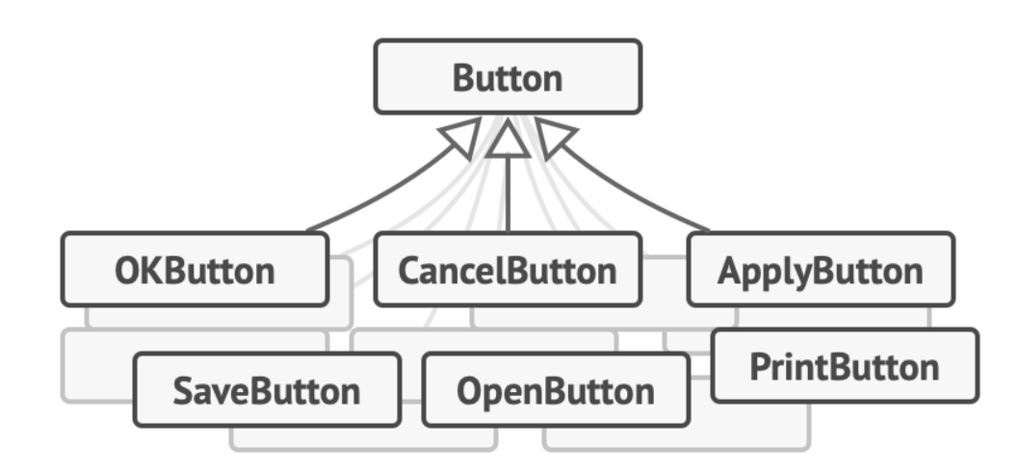

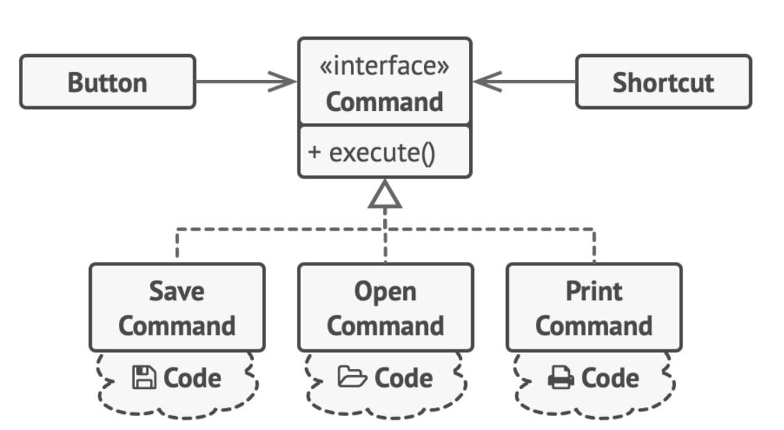

*class* Light {  
  
 *private boolean* switchedOn = *false*;  
  
 *public void* switchLights() {  
 switchedOn = !switchedOn;  
 System.*out*.println("Light is now " + (switchedOn ? "ON" : "OFF"));  
 }  
  
 *public boolean* isSwitchedOn() {  
 *return* switchedOn;  
 }  
}  
  
*interface Command* {  
 *void* turnOn();  
 *void* turnOff();  
}  
  
*class* LightCommand *implements Command* {  
 *private* Light light;  
  
 *public* LightCommand(Light light) {  
 *this*.light = light;  
 }  
  
 *public void* turnOn() {  
 *if* (!light.isSwitchedOn()) {  
 light.switchLights();  
 } *else* {  
 System.*out*.println("Light is already ON");  
 }  
 }  
  
 *public void* turnOff() {  
 *if* (light.isSwitchedOn()) {  
 light.switchLights();  
 } *else* {  
 System.*out*.println("Light is already OFF");  
 }  
 }  
}  
  
*class* RemoteControl {  
 *private Command* command;  
  
 *public* RemoteControl(*Command* command) {  
 *this*.command = command;  
 }  
  
 *public void* pressOnButton() {  
 command.turnOn();  
 }  
  
 *public void* pressOffButton() {  
 command.turnOff();  
 }  
}  
  
*public class* CommandPattern {  
 *public static void* main(String[] args) {  
 Light light = *new* Light();  
 *Command* lightCommand = *new* LightCommand(light);  
 RemoteControl remoteControl = *new* RemoteControl(lightCommand);  
  
 remoteControl.pressOnButton(); *// Light is now ON* remoteControl.pressOffButton(); *// Light is now OFF* remoteControl.pressOffButton(); *// Light is already OFF* remoteControl.pressOnButton(); *// Light is now ON* }  
}

[PlantUML Web Server](https://www.plantuml.com/plantuml/uml/SyfFKj2rKt3CoKnELR1Io4ZDoSa700002)

@startuml

skinparam handwritten true

skinparam shadowing false

interface Command {

+ turnOn(): void

+ turnOff(): void

}

class Light {

- switchedOn: boolean

+ switchLights(): void

+ isSwitchedOn(): boolean

}

class LightCommand {

- light: Light

+ LightCommand(light: Light)

+ turnOn(): void

+ turnOff(): void

}

class RemoteControl {

- command: Command

+ RemoteControl(command: Command)

+ pressOnButton(): void

+ pressOffButton(): void

}

class CommandPatternDemo {

+ main(args: String[]): void {static}

}

' Relationships'

Command <|.. LightCommand : implements

LightCommand o-- Light : "1" has "1"

RemoteControl o-- Command : "1" has "1"

CommandPatternDemo ..> Light : uses

CommandPatternDemo ..> LightCommand : uses

CommandPatternDemo ..> RemoteControl : uses

@enduml

