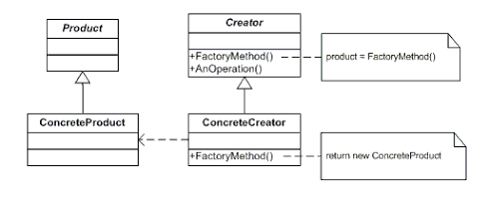
// Step 1 — Interface
interface Notification {
void notifyUser();
}
// Step 2 — Implementations
class EmailNotification implements Notification {
@Override
public void notifyUser() {
System.out.println("Sending Email Notification");
}
}
class SMSNotification implements Notification {
@Override
public void notifyUser() {
System.out.println("Sending SMS Notification");
}
}
class PushNotification implements Notification {
@Override
public void notifyUser() {
System.out.println("Sending Push Notification");
}
}
// Step 3 — Factory Class
/*
class NotificationFactory {
public static Notification createNotification(String type) {
if(type == null) {
return null;
}
if(type.equalsIgnoreCase("EMAIL")) {
return new EmailNotification();
}
if(type.equalsIgnoreCase("SMS")) {
return new SMSNotification();
}
return null;
}
}
*/
/*class NotificationFactory {
private static final Map<String, Supplier<Notification>> notificationMap =
Map.of(
"EMAIL", EmailNotification::new,
"SMS", SMSNotification::new,
"PUSH", PushNotification::new
);
public static Notification createNotification(String type) {
Supplier<Notification> supplier =
notificationMap.get(type.toUpperCase());
if (supplier != null) {
return supplier.get();
}
throw new IllegalArgumentException(
"Invalid notification type: " + type);
}
}*/
class NotificationFactory {
private static final ConcurrentHashMap<String,
Supplier<Notification>> registry =
new ConcurrentHashMap<>();
static {
registry.put("EMAIL", EmailNotification::new);
registry.put("SMS", SMSNotification::new);
registry.put("PUSH", PushNotification::new);
}
public static Notification createNotification(String type) {
Supplier<Notification> supplier =
registry.get(type.toUpperCase());
if (supplier != null) {
return supplier.get();
}
throw new IllegalArgumentException(
"Invalid notification type: " + type);
}
}
// Step 4 — Client Code
public class FactoryEmailSMS {
public static void main(String[] args) {
Notification notification1 =
NotificationFactory.createNotification("EMAIL");
notification1.notifyUser();
Notification notification2 =
NotificationFactory.createNotification("SMS");
notification2.notifyUser();
Notification notification3 =
NotificationFactory.createNotification("PUSH");
notification3.notifyUser();
}
}

Why factory instead of new?
Because:
- object creation may become complex
- creation logic may change
- helps dependency inversion
Encapsulation: Hides the instantiation logic from the client.
Loose coupling - Client doesn't know concrete classes
Single Responsibility - Creation logic in one place
Open/Closed Principle - Add new types without changing existing code
Common Use Cases
- Database connections - Different DB types (MySQL, PostgreSQL, MongoDB)
- Logging frameworks - File, console, database loggers
- Document parsers - PDF, Word, Excel parsers
- UI frameworks - Different OS themes
- Payment gateways - Multiple payment providers
The Factory Pattern is one of the most commonly used design patterns in Java frameworks like Spring, Hibernate, and JDBC!

