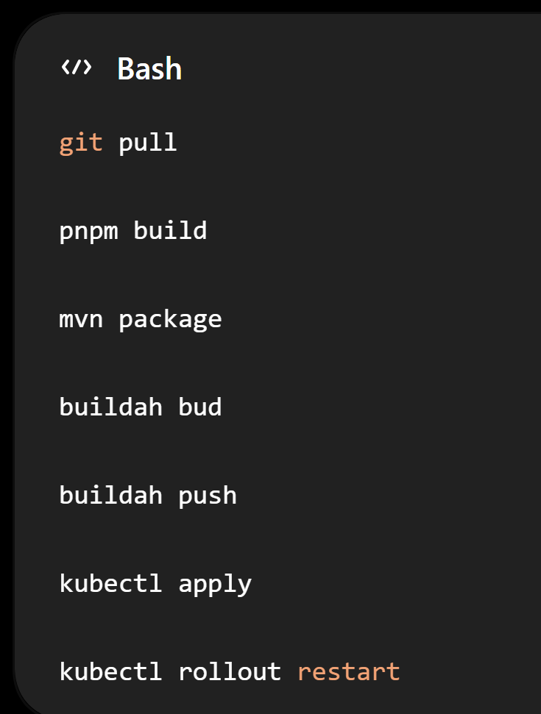
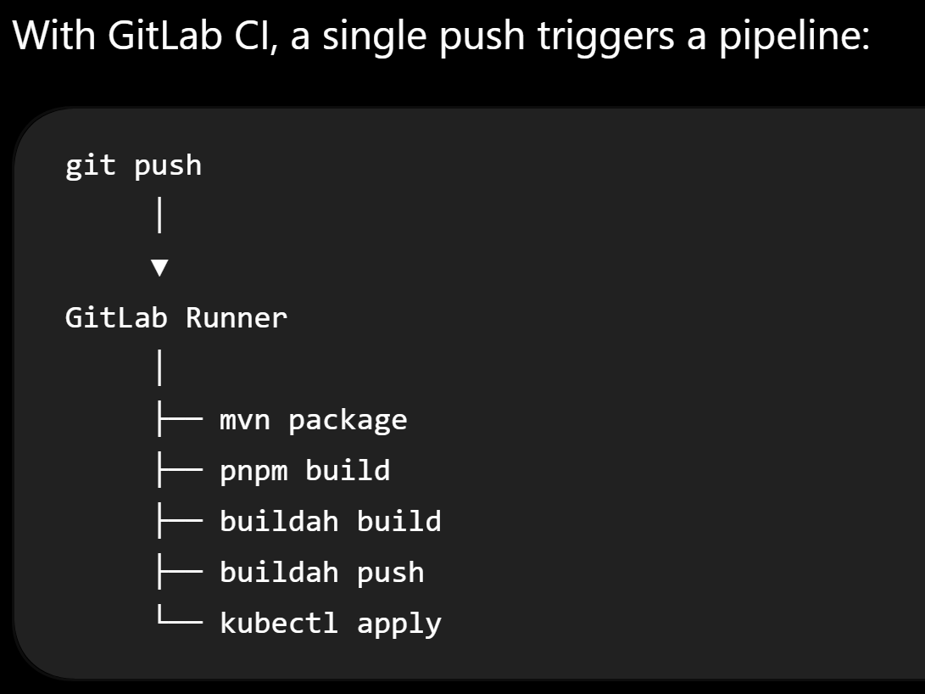
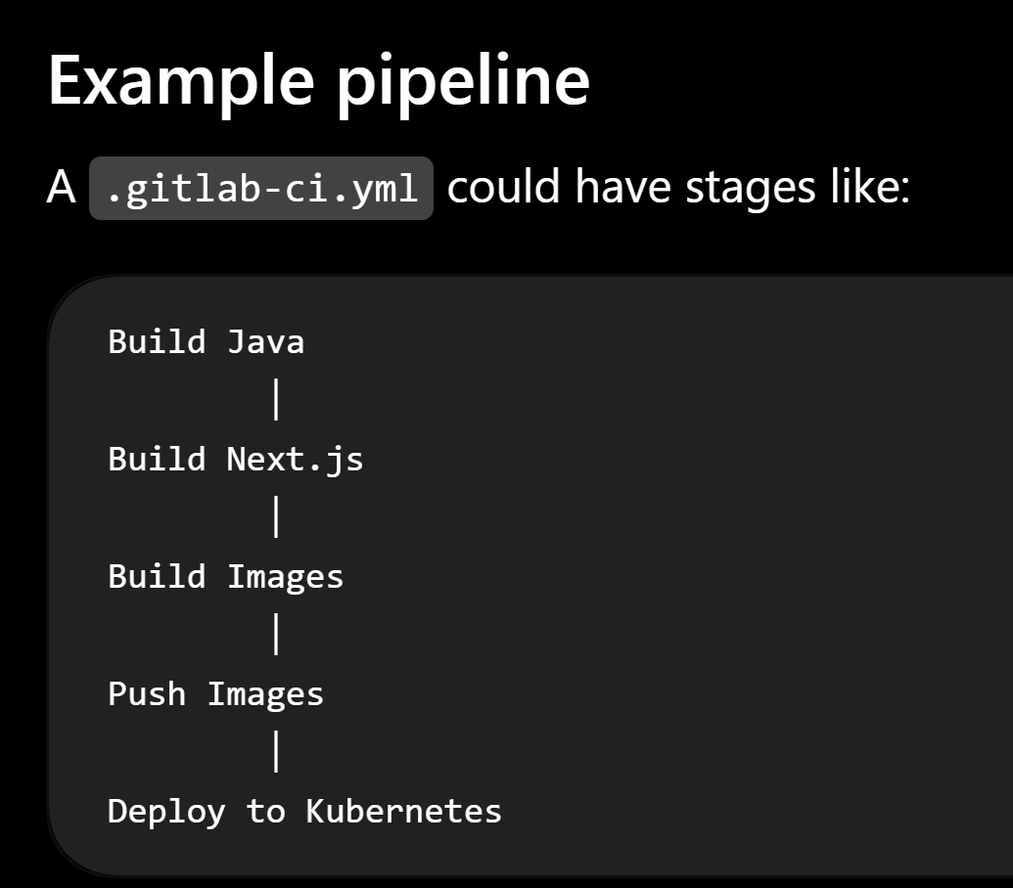

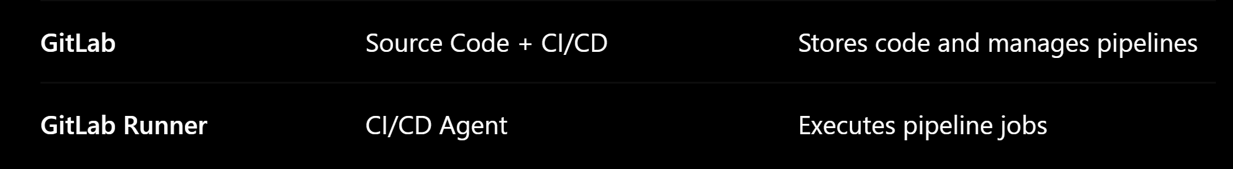

GitLab | Source Code + CI/CD | Stores code and manages pipelines
GitLab Runner | CI/CD Agent | Executes pipeline jobs

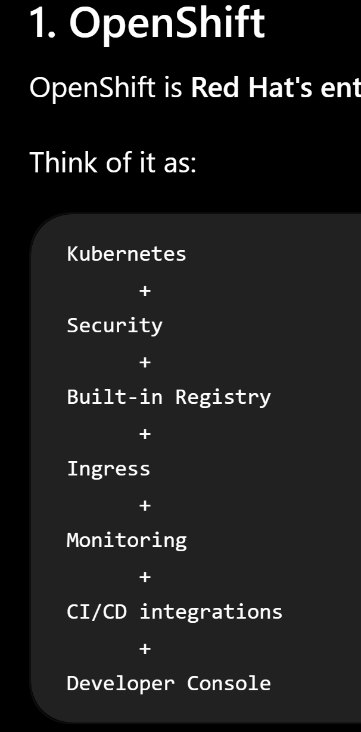
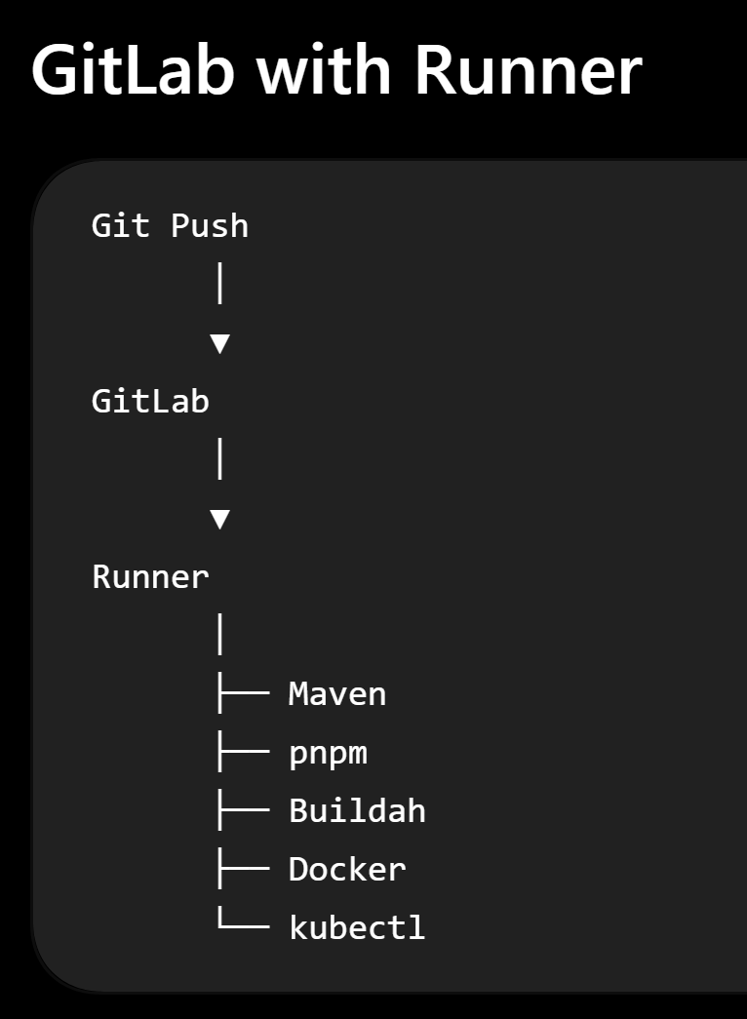
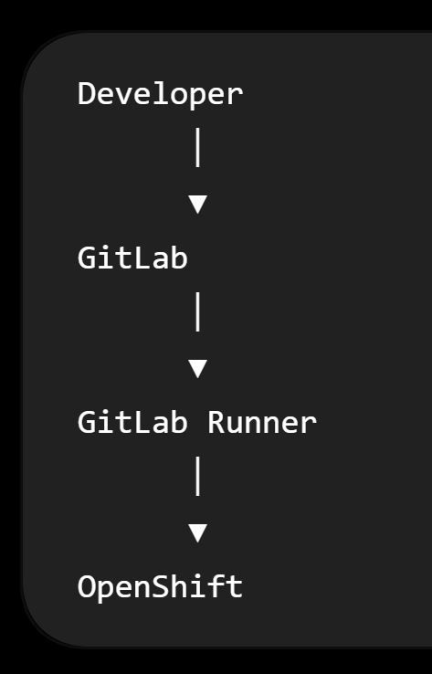
• Kubernetes
• Helm
• Ingress
• Prometheus/Grafana
• Redis
• Kafka
• GitLab CI + GitLab Runner
• Argo CD (GitOps)
• OpenShift
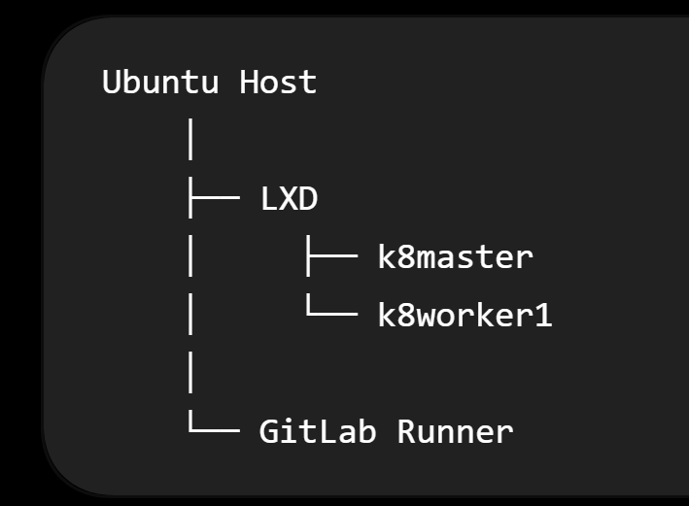

- Create a GitLab project.
- Register a GitLab Runner.
- Write .gitlab-ci.yml.
- Build Java with Maven.
- Build Next.js with pnpm.
- Build images with Buildah.
- Push images to your local registry.
- Deploy to Kubernetes automatically.
- Use pipeline variables and secrets.

