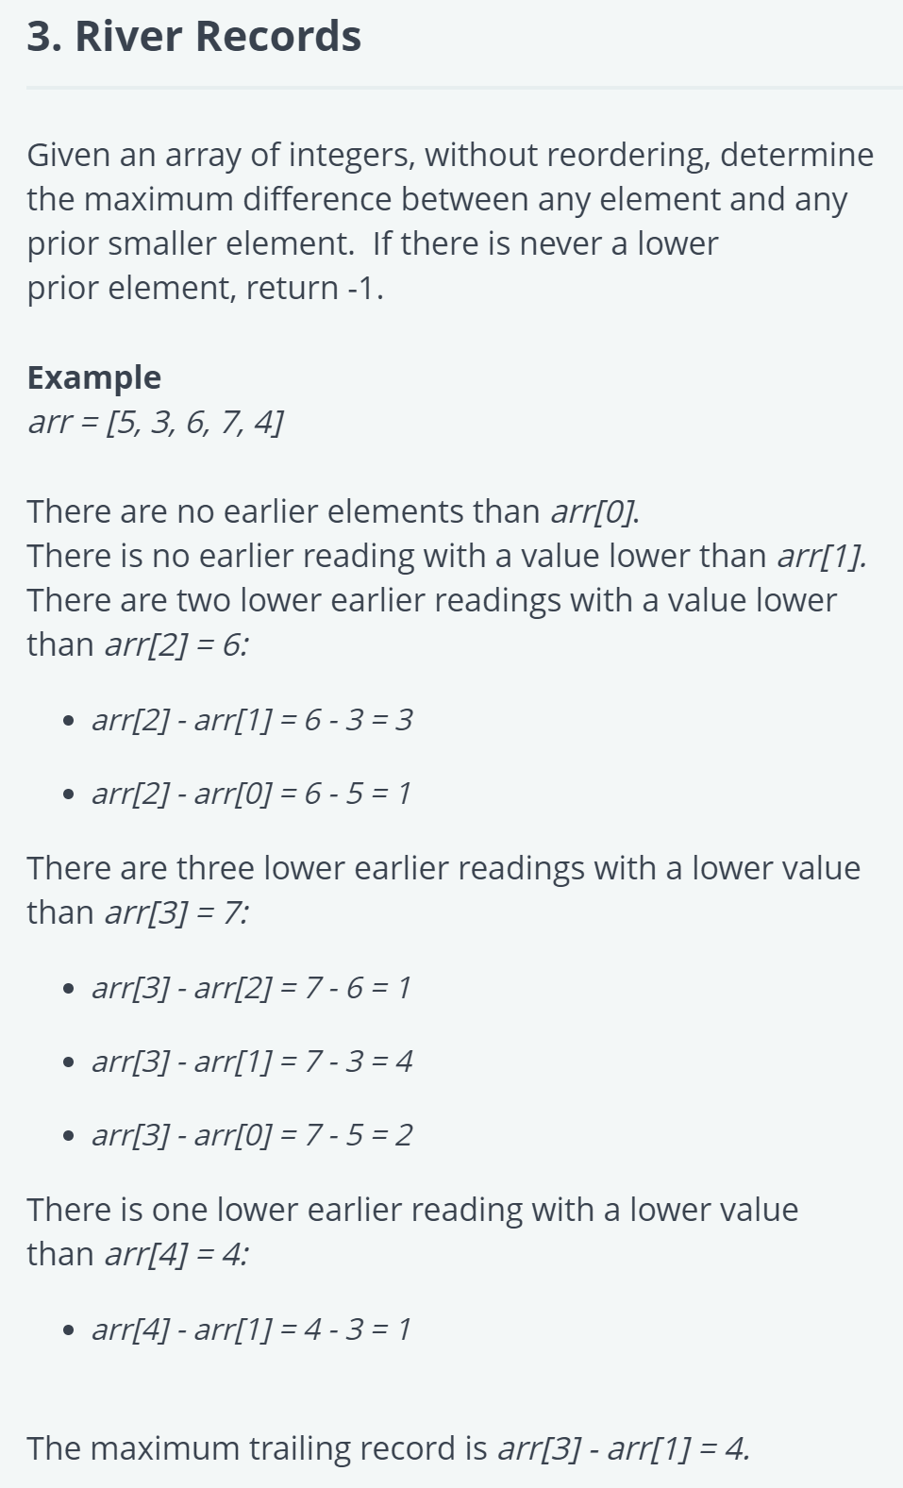

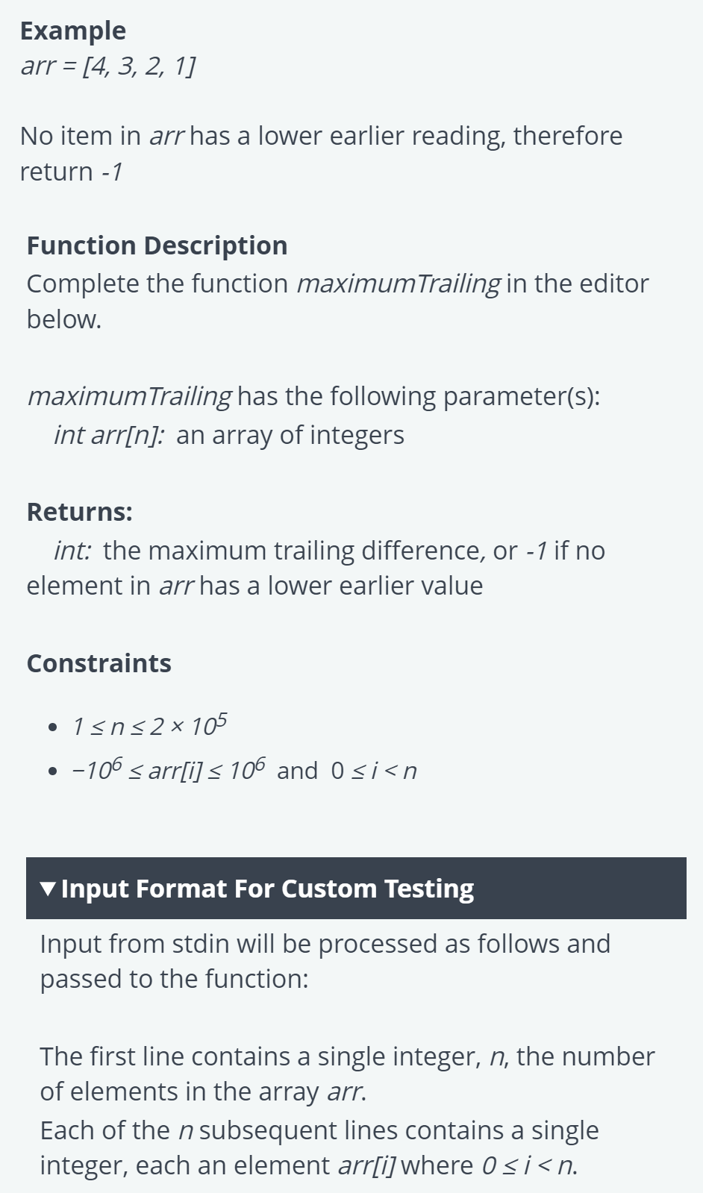

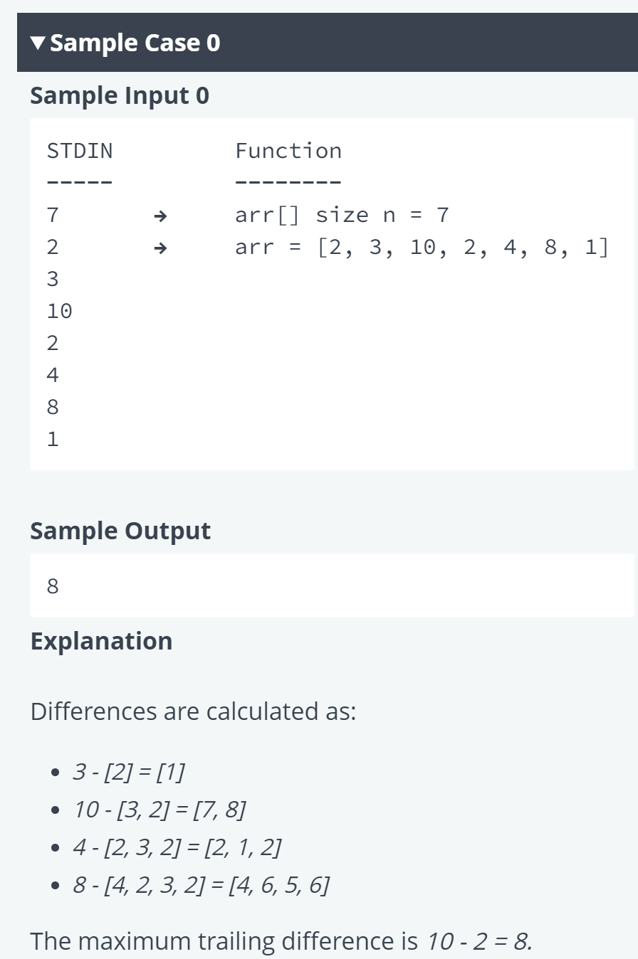

*public class* RiverRecords {  
  
 *public static int* maxTrailing(*List*<Integer> arr) {  
 *if* (arr.isEmpty()) *return* -1; *// If the list is empty, return -1  
  
 int* maxTrailingDifference = -1; *// Initialize the maximum trailing difference to -1  
 int* minSoFar = arr.get(0); *// Initialize the minimum element seen so far to the first element  
  
 for* (*int* i = 1; i < arr.size(); i++) {  
 *int* current = arr.get(i);  
 *int* difference = current - minSoFar;  
  
 *if* (difference > 0 && (maxTrailingDifference == -1 || difference > maxTrailingDifference)) {  
 maxTrailingDifference = difference;  
 }  
  
 *if* (current < minSoFar) {  
 minSoFar = current; *// Update the minimum element seen so far* }  
 }  
  
 *return* maxTrailingDifference;  
 }  
  
 *public static void* main(String[] args) {  
 *// Example usage:  
 List*<Integer> arr1 = *List*.*of*(2, 3, 10, 2, 4, 8, 1);  
 System.*out*.println(*maxTrailing*(arr1)); *// Output: 8  
  
 List*<Integer> arr2 = *List*.*of*(4, 3, 2, 1);  
 System.*out*.println(*maxTrailing*(arr2)); *// Output: -1* }  
}