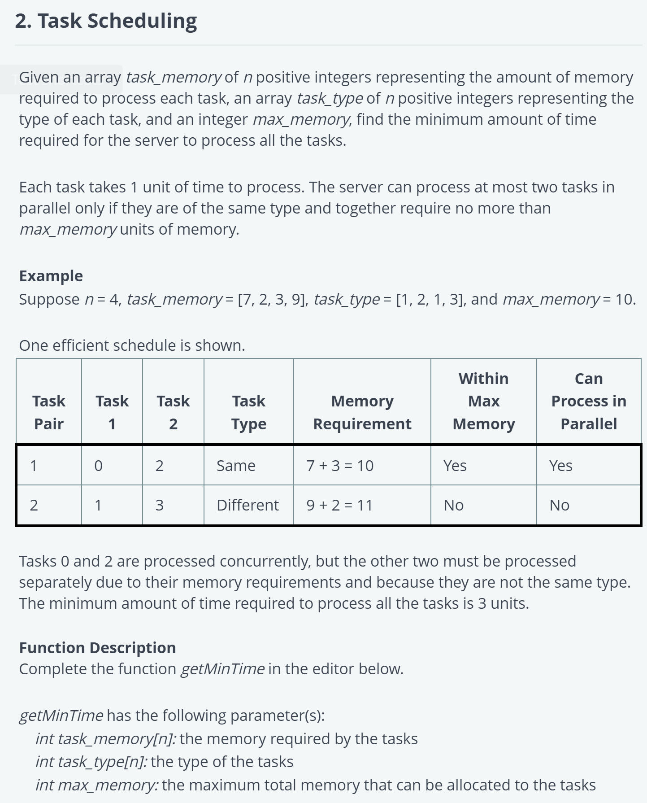

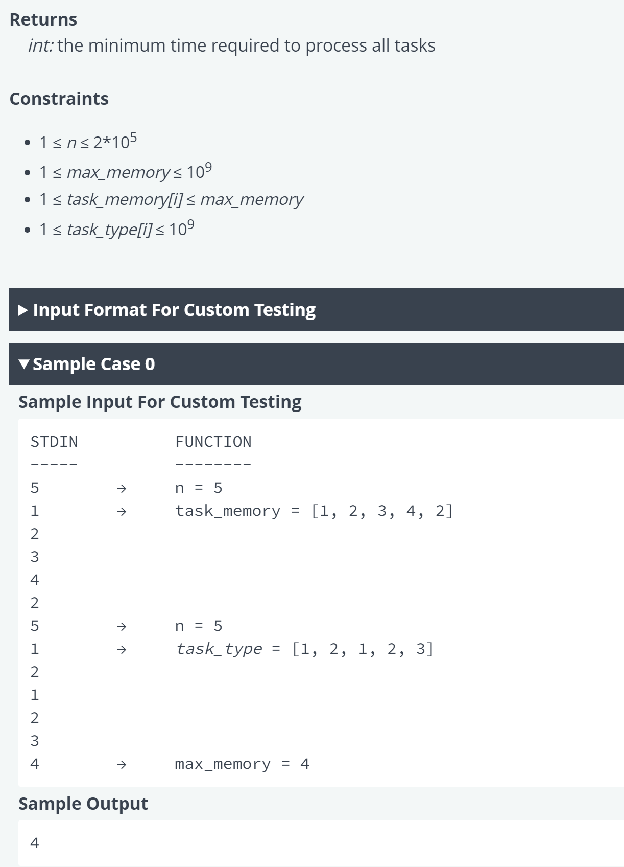

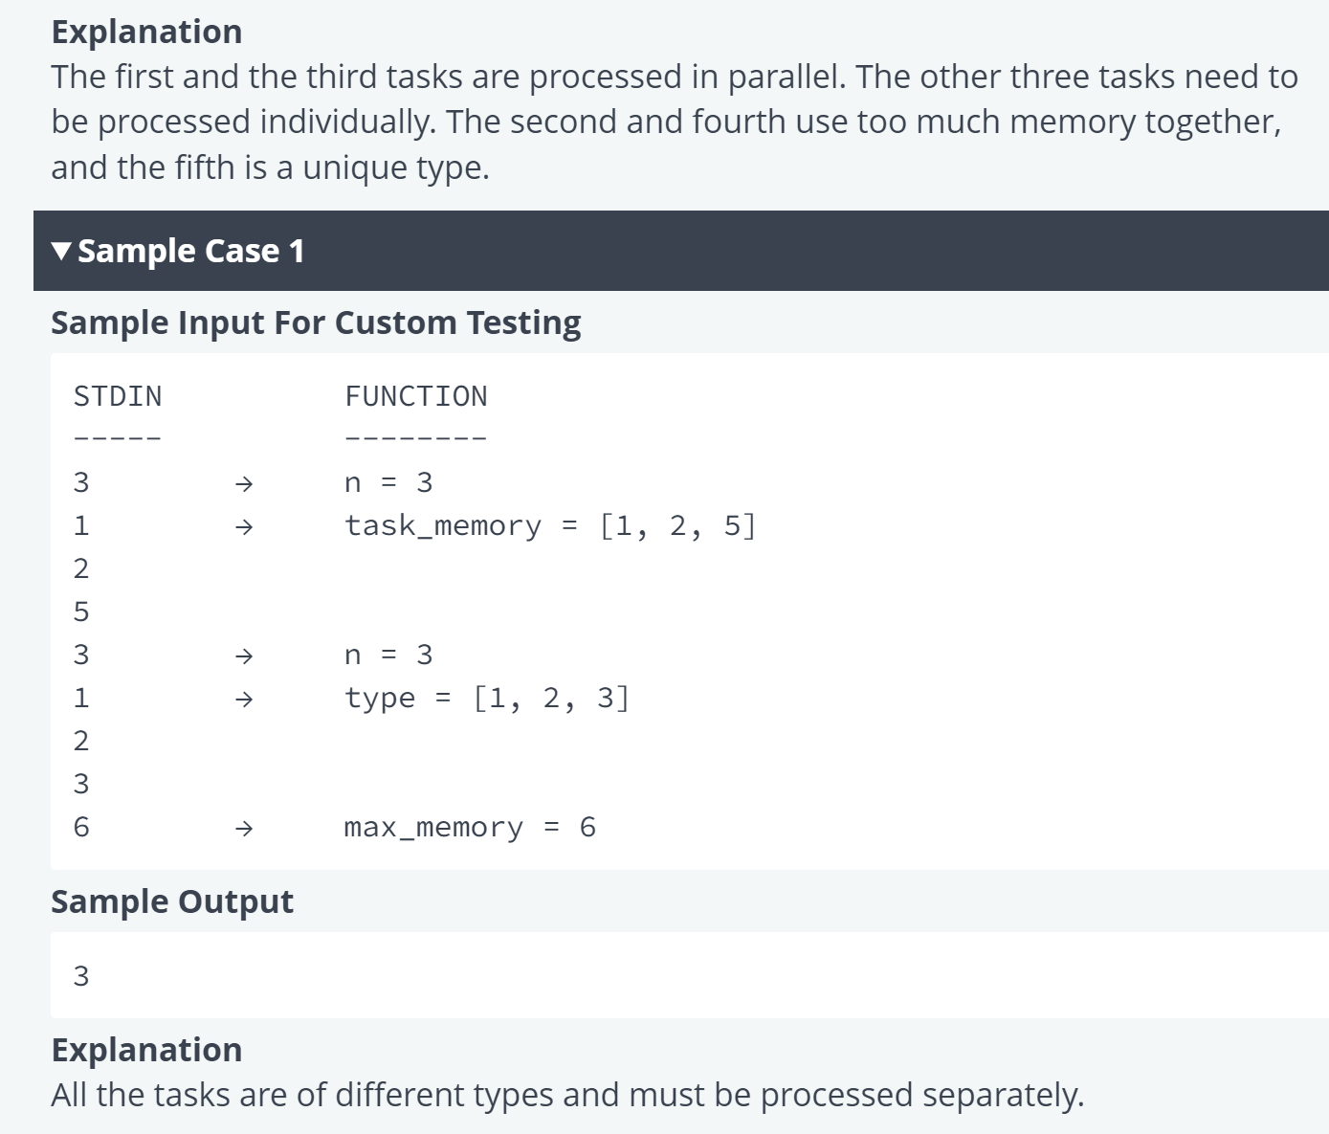

*public class* TaskScheduling {  
  
  
 *public static int* getMinTime(*List*<Integer> task_memory, *List*<Integer> task_type, *int* max_memory) {  
 *int* minTime = 0;  
 *Map*<Integer, Integer> typeToMemory = *new* HashMap<>();  
  
 *for* (*int* i = 0; i < task_memory.size(); i++) {  
 *int* memory = task_memory.get(i);  
 *int* type = task_type.get(i);  
  
 *if* (typeToMemory.containsKey(type)) {  
 *int* totalMemory = typeToMemory.get(type) + memory;  
 *if* (totalMemory <= max_memory) {  
 typeToMemory.put(type, totalMemory);  
 } *else* {  
 minTime++; *// Process the task separately* typeToMemory.put(type, memory);  
 }  
 } *else* {  
 typeToMemory.put(type, memory);  
 minTime++; *// Process the first task separately* }  
 }  
  
 *return* minTime;  
 }  
  
  
 *public static void* main(String[] args) {  
 *List*<Integer> task_memory = *List*.*of*(1, 2, 3, 4, 2);  
 *List*<Integer> task_type = *List*.*of*(1, 2, 1, 2, 3);  
 *int* max_memory = 4;  
 System.*out*.println(*getMinTime*(task_memory, task_type, max_memory)); *// Output: 4* task_memory = *List*.*of*(20, 17, 18, 13, 11, 13, 19, 15, 13, 10, 13, 12, 11, 15, 19, 16, 10, 11, 14, 18, 19);  
 task_type = *List*.*of*(20, 4, 3, 4, 1, 1, 3, 3, 4, 2, 2, 4, 3, 5, 1, 3, 4, 3, 2, 3, 1);  
 max_memory = 213;  
 System.*out*.println(*getMinTime*(task_memory, task_type, max_memory)); *// Output: 12* }  
}