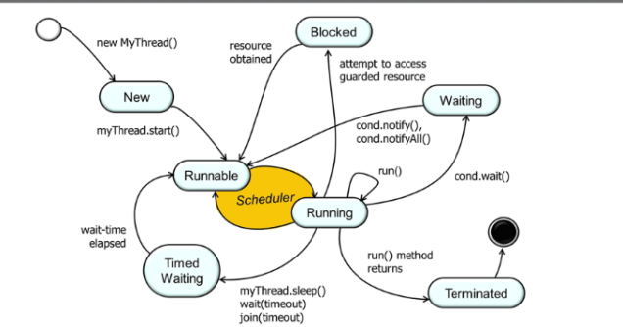

- When a java process initialize a new thread, its in the New state.
- After the program calls the start method of the thread, the thread state transition to the Runnable state
- When the thread scheduler selects this thread for execution, the thread state is changed to RUNNING state in which the java virtual machine invokes the Thread run hook method
- If there is any wait operation called from the thread (sleep, wait or join method), the thread state transition to Timed Waiting state
- When this waiting time elapses, the thread is back to RUNNABLE state and is eligible for the Thread scheduler selection .
- After the thread start executing its run method, it may access a guarded resources like a synchronized method or a state protected by a monitor lock which will transition the thread to BLOCKED state if the resource is not yet available
- Once the resource is available, the thread can access the guarded resource and will transition to RUNNABLE state
- Once the thread start running again, it might wait for a monitor condition like wait() method changing the thread state to WAITING state.
- When the other threads notifies the wait condition with notify or notifyAll method, the thread again becomes RUNNABLE
- Finally, when a RUNNING thread completes its execution, it gets TERMINATED.

