Strategy 1: Query Parameter Versioning (use.query-parameter)
# Enable query parameter checking and define the parameter key to look for
spring.mvc.apiversion.use.query-parameter=version

# Optional: Set baseline defaults and supported boundaries
spring.mvc.apiversion.default=1.0
spring.mvc.apiversion.supported=1.0,2.0
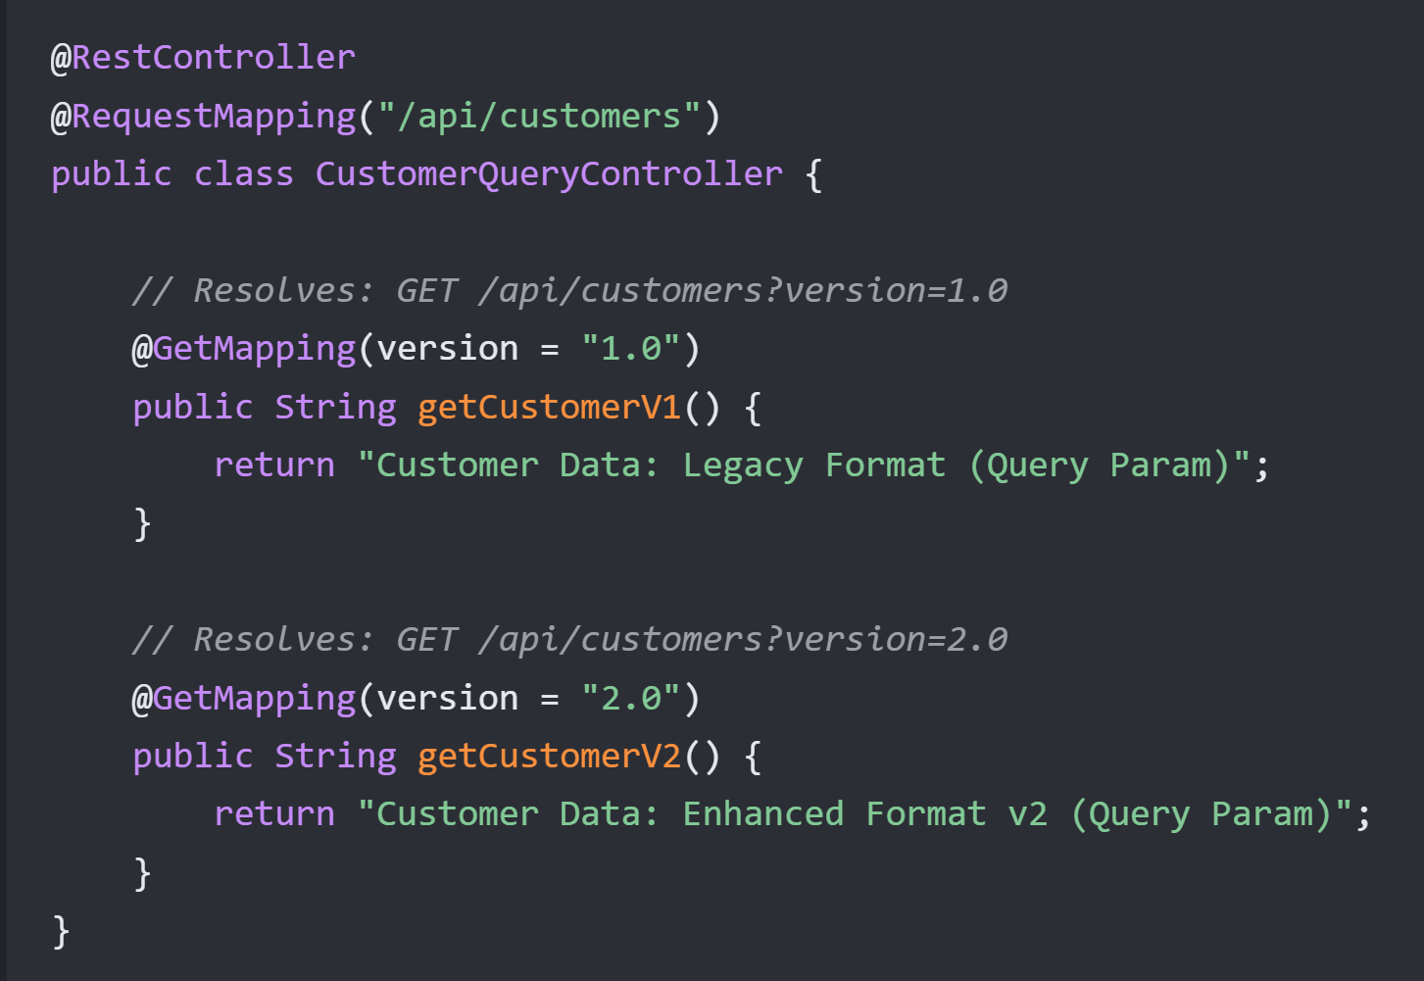
Strategy 2: Request Header Versioning (use.header)
properties# Instruct Spring Boot to read version data from a custom HTTP Header
spring.mvc.apiversion.use.header=X-API-Version

spring.mvc.apiversion.default=1.0
spring.mvc.apiversion.supported=1.0,2.0
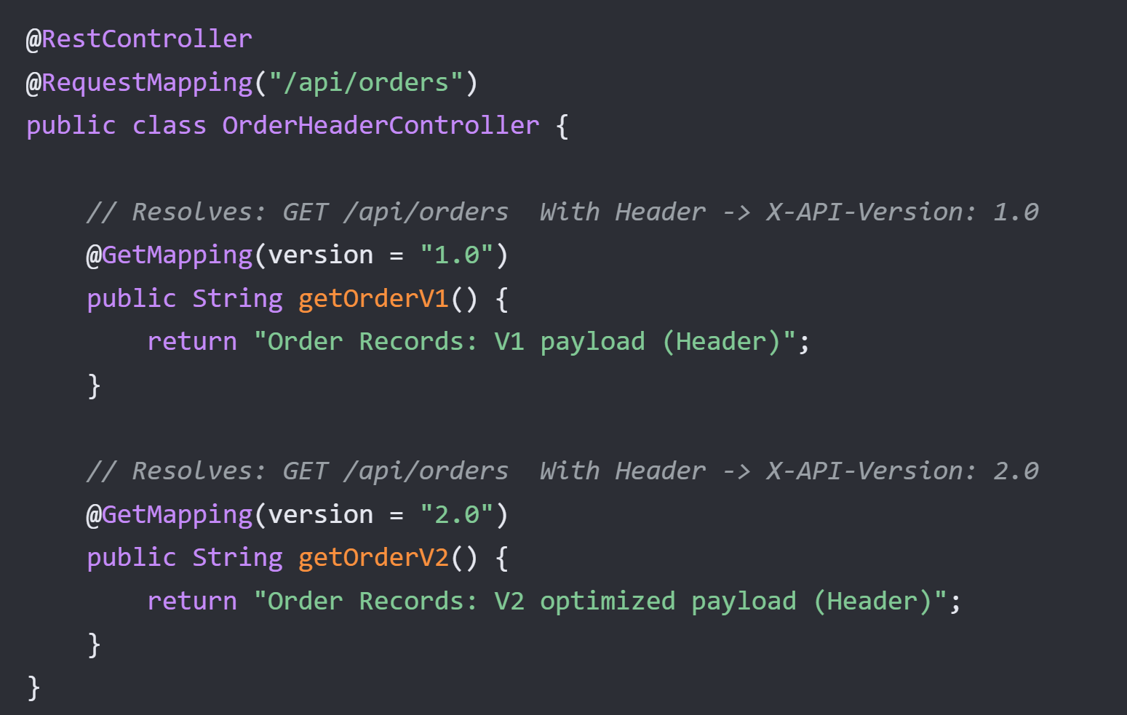
Strategy 3: URI Path Segment Versioning
properties# Identify the exact 0-indexed URI path segment holding the version token.
# In the URL path pattern "/api/{v}/products", segment 0 is "api", segment 1 is the version.
spring.mvc.apiversion.use.path-segment=1

spring.mvc.apiversion.default=1.0
spring.mvc.apiversion.supported=1.0,2.0
