[Which equals operator (== vs ===) should be used in JavaScript comparisons? - Stack Overflow](https://stackoverflow.com/questions/359494/which-equals-operator-vs-should-be-used-in-javascript-comparisons#:~:text=The%20%3D%3D%20operator%20will%20compare,Both%20are%20equally%20quick.)

The == operator compares the values of two variables after performing type conversion if necessary. On the other hand, the === operator compares the values of two variables without performing type conversion.

'' == '0' // false

0 == '' // true

0 == '0' // true

'' == '0' // false

0 == '' // true

0 == '0' // true

false == undefined // false

false == null // false

null == undefined // true

"abc" == new String("abc") // true

"abc" === new String("abc") // false

Here the == operator is checking the values of the two objects and returning true

I prefer == here in this use case

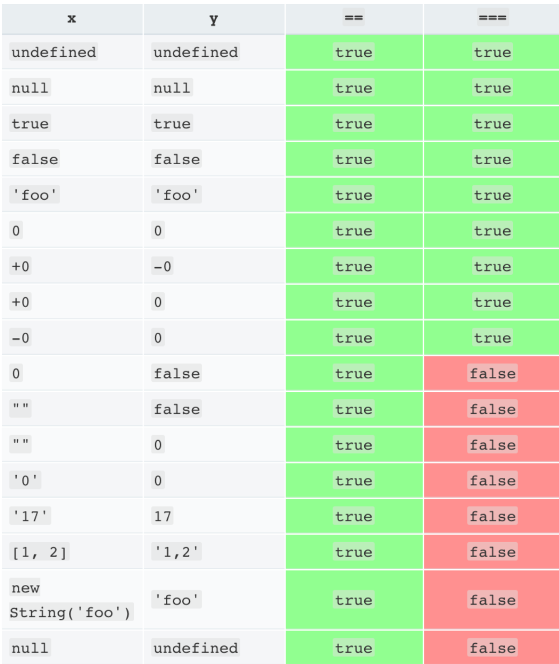

true == 1; //true, because 'true' is converted to 1 and then compared

"2" == 2; //true, because "2" is converted to 2 and then compared

