**wait**

Object wait methods has three variance, one which waits indefinitely for any other thread to call notify or notifyAll method on the object to wake up the current thread.

**notify**

notify method wakes up only one thread waiting on the object and that thread starts execution.

**notifyAll**

notifyAll method wakes up all the threads waiting on the object, although which one will process first depends on the OS implementation.

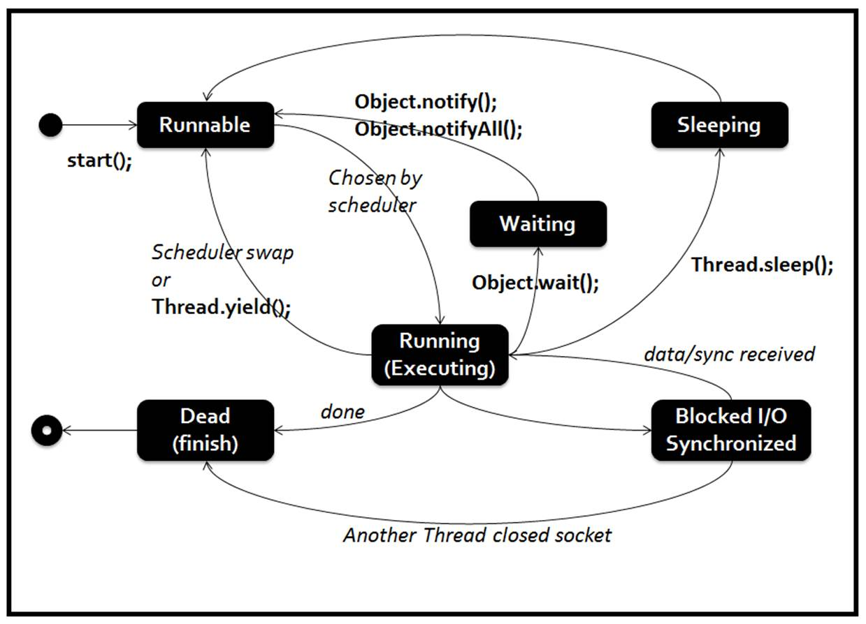

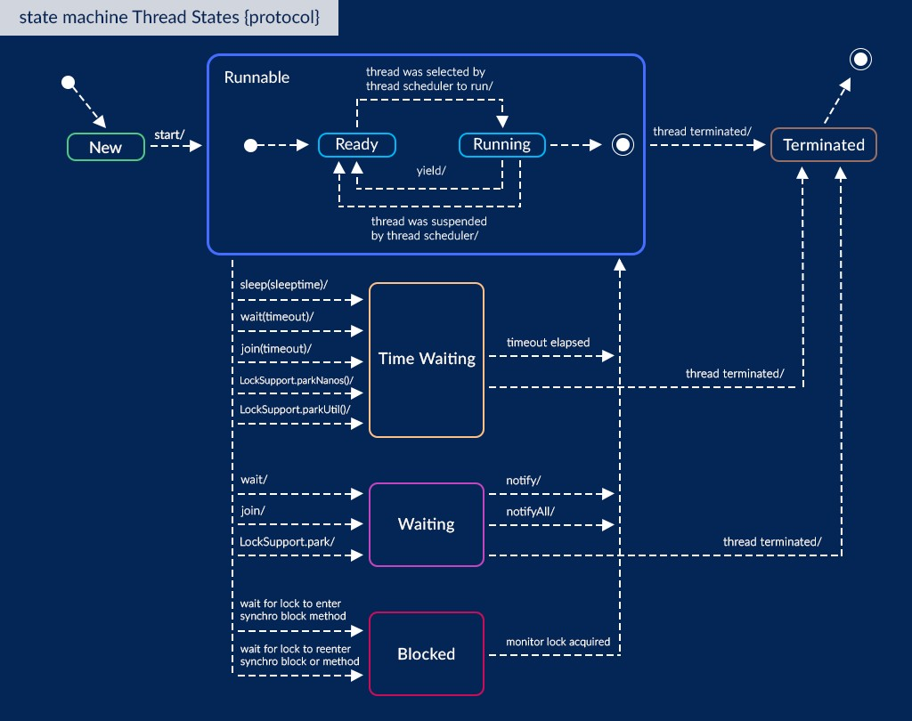

[*https://raw.githubusercontent.com/vsaravanan/java22/master/src/main/java/com/saravanjs/java22/console/multithreading/WaitNotifyTest.java*](https://raw.githubusercontent.com/vsaravanan/java22/master/src/main/java/com/saravanjs/java22/console/multithreading/WaitNotifyTest.java)

[Java Thread wait, notify and notifyAll Example | DigitalOcean](https://www.digitalocean.com/community/tutorials/java-thread-wait-notify-and-notifyall-example)

*class* Message {  
 *private* String msg;  
  
 *public* Message(String str){  
 *this*.msg=str;  
 }  
  
 *public* String getMsg() {  
 *return* msg;  
 }  
  
 *public void* setMsg(String str) {  
 *this*.msg=str;  
 }  
  
}  
  
*class* Waiter *implements Runnable*{  
  
 *private* Message msg;  
  
 *public* Waiter(Message m){  
 *this*.msg=m;  
 }  
  
 @Override  
 *public void* run() {  
 String name = Thread.*currentThread*().getName();  
 *synchronized* (msg) {  
 *try*{  
 System.*out*.println(name+" waiting to get notified at time:"+System.*currentTimeMillis*());  
 msg.wait();  
 }*catch*(InterruptedException e){  
 e.printStackTrace();  
 }  
 System.*out*.println(name+" waiter thread got notified at time:"+System.*currentTimeMillis*());  
 *//process the message now* System.*out*.println(name+" processed: "+msg.getMsg());  
 }  
 }  
  
}  
  
*class* Notifier *implements Runnable* {  
  
 *private* Message msg;  
  
 *public* Notifier(Message msg) {  
 *this*.msg = msg;  
 }  
  
 @Override  
 *public void* run() {  
 String name = Thread.*currentThread*().getName();  
 System.*out*.println(name+" started");  
 *try* {  
 Thread.*sleep*(1000);  
 *synchronized* (msg) {  
 msg.setMsg(name+" Notifier work done");  
 msg.notify();  
*// msg.notifyAll();* }  
 } *catch* (InterruptedException e) {  
 e.printStackTrace();  
 }  
  
 }  
  
}  
  
*public class* WaitNotifyTest {  
  
 *public static void* main(String[] args) {  
 Message msg = *new* Message("process it");  
 Waiter waiter = *new* Waiter(msg);  
 *new* Thread(waiter,"waiter").start();  
  
 Waiter waiter1 = *new* Waiter(msg);  
 *new* Thread(waiter1, "waiter1").start();  
  
 Notifier notifier = *new* Notifier(msg);  
 *new* Thread(notifier, "notifier").start();  
 System.*out*.println("All the threads are started");  
 }  
  
}

for msg.notify();

All the threads are started

notifier started

waiter waiting to get notified at time:1718699314333

waiter1 waiting to get notified at time:1718699314342

waiter waiter thread got notified at time:1718699315335

waiter processed: notifier Notifier work done

for msg.notifyAll();

All the threads are started

notifier started

waiter waiting to get notified at time:1718699488848

waiter1 waiting to get notified at time:1718699488860

waiter waiter thread got notified at time:1718699489854

waiter processed: notifier Notifier work done

waiter1 waiter thread got notified at time:1718699489858

waiter1 processed: notifier Notifier work done