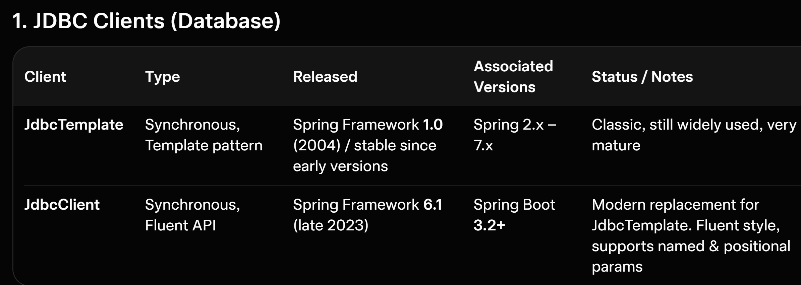
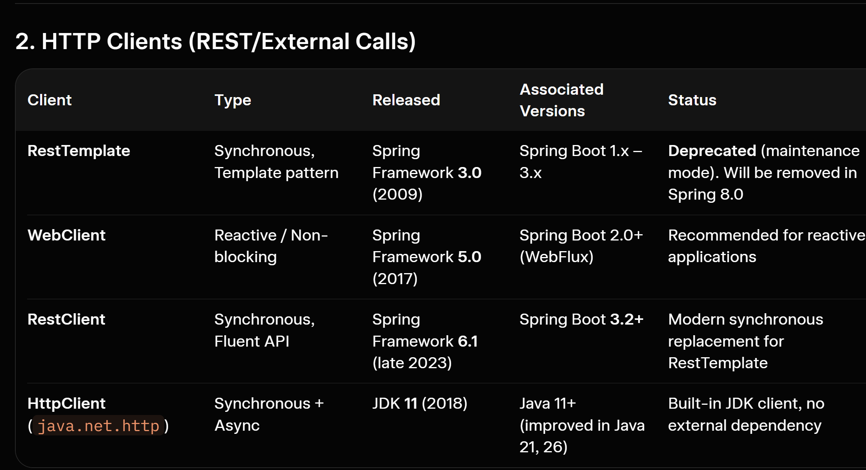

1. JDBC Clients (Database)
Client | Type | Released | Associated Versions | Status / Notes
JdbcTemplate | Synchronous, Template pattern | Spring Framework 1.0 (2004) / stable since early versions | Spring 2.x – 7.x | Classic, still widely used, very mature
JdbcClient | Synchronous, Fluent API | Spring Framework 6.1 (late 2023) | Spring Boot 3.2+ | Modern replacement for JdbcTemplate. Fluent style, supports named & positional params
JdbcClient is the new recommended synchronous JDBC API in modern Spring.

2. HTTP Clients (REST/External Calls)
Client | Type | Released | Associated Versions | Status
RestTemplate | Synchronous, Template pattern | Spring Framework 3.0 (2009) | Spring Boot 1.x – 3.x | Deprecated (maintenance mode). Will be removed in Spring 8.0
WebClient | Reactive / Non-blocking | Spring Framework 5.0 (2017) | Spring Boot 2.0+ (WebFlux) | Recommended for reactive applications
RestClient | Synchronous, Fluent API | Spring Framework 6.1 (late 2023) | Spring Boot 3.2+ | Modern synchronous replacement for RestTemplate
HttpClient (java.net.http) | Synchronous + Async | JDK 11 (2018) | Java 11+ (improved in Java 21, 26) | Built-in JDK client, no external dependency

Quick Recommendation (2026)
- New projects:
  - Synchronous → Use JdbcClient + RestClient
  - Reactive → Use WebClient
- Existing projects:
  - Still on RestTemplate? Plan migration to RestClient
  - Still on JdbcTemplate? You can keep it, but JdbcClient is cleaner for new code

Summary Timeline
- 2004–2009: Old era → JdbcTemplate + RestTemplate
- 2017–2018: Reactive era → WebClient (Spring 5) + HttpClient (JDK 11)
- 2023 (Spring 6.1 / Boot 3.2): Modern fluent era → JdbcClient + RestClient
RestTemplate is being phased out (announced deprecation path in 2025).
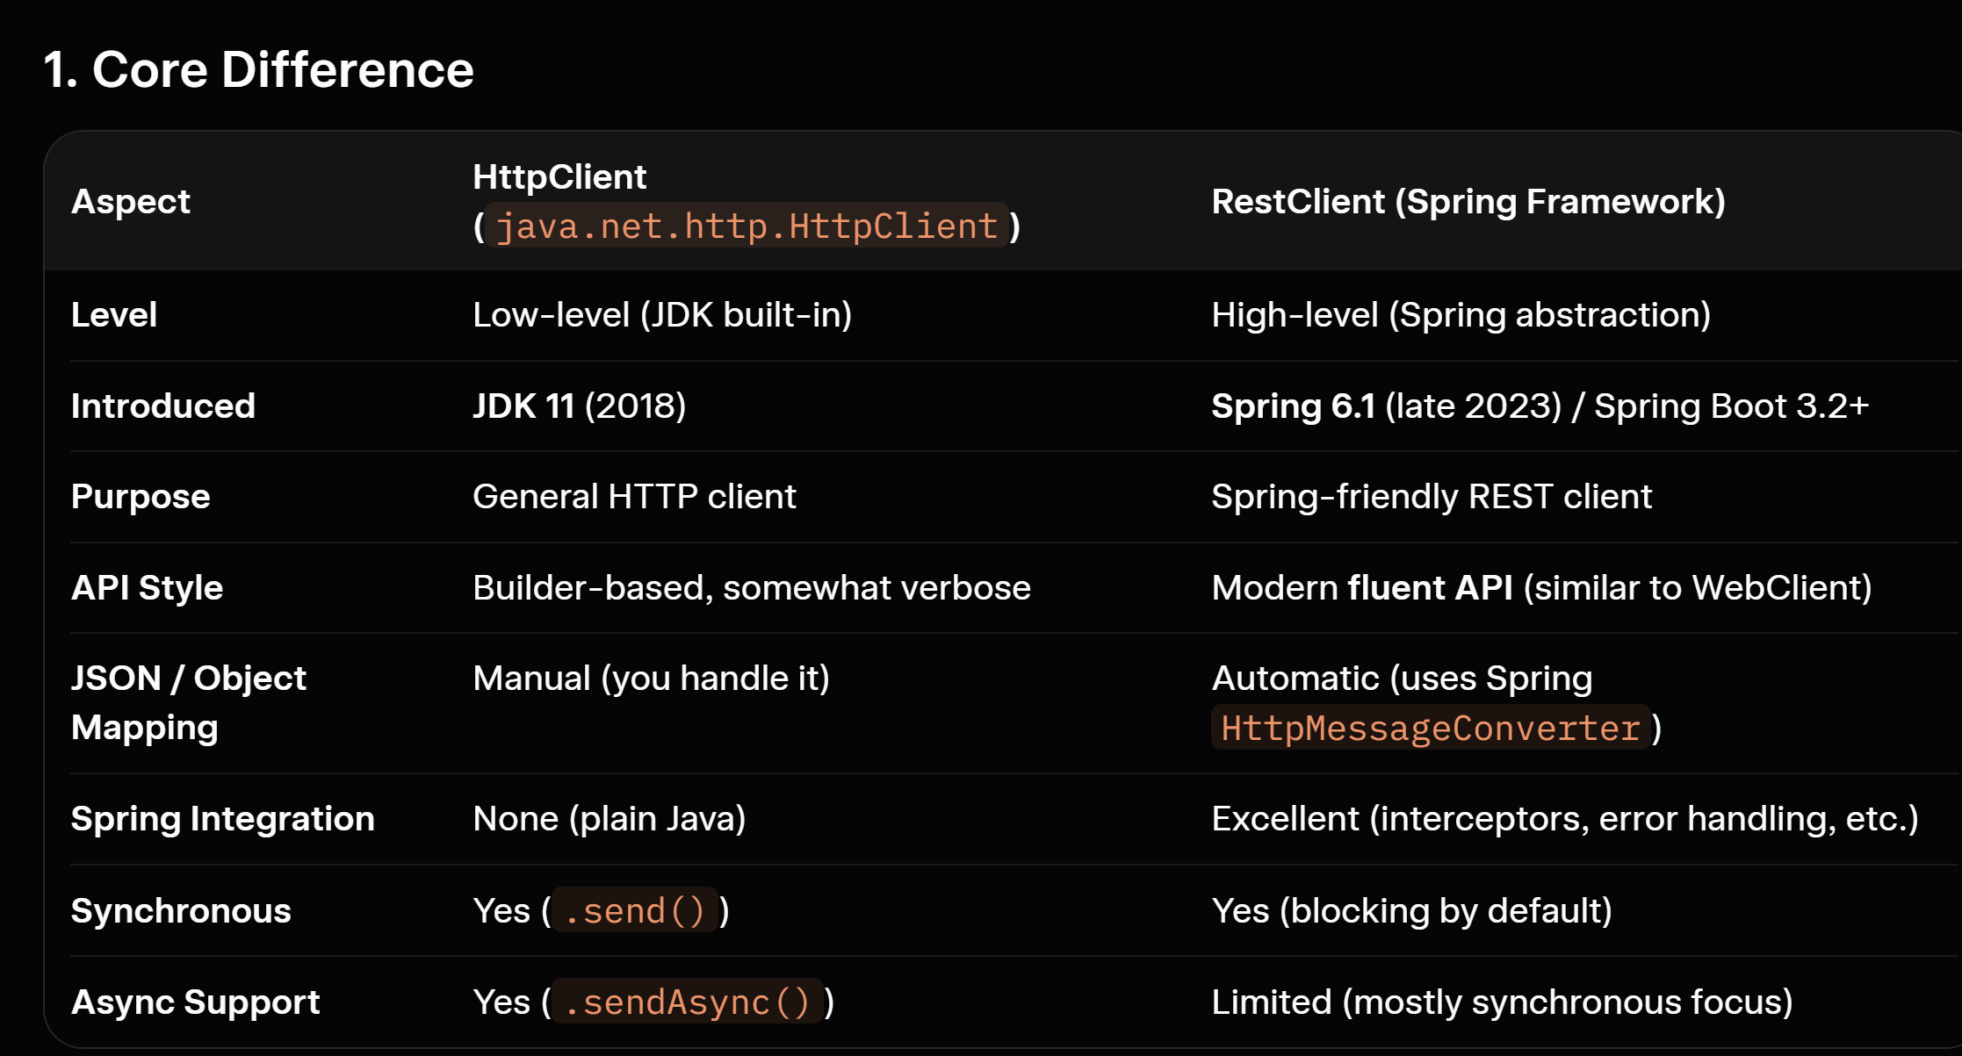
1. Core Difference
Aspect | HttpClient (java.net.http.HttpClient) | RestClient (Spring Framework)
Level | Low-level (JDK built-in) | High-level (Spring abstraction)
Introduced | JDK 11 (2018) | Spring 6.1 (late 2023) / Spring Boot 3.2+
Purpose | General HTTP client | Spring-friendly REST client
API Style | Builder-based, somewhat verbose | Modern fluent API (similar to WebClient)
JSON / Object Mapping | Manual (you handle it) | Automatic (uses Spring HttpMessageConverter)
Spring Integration | None (plain Java) | Excellent (interceptors, error handling, etc.)
Synchronous | Yes (.send()) | Yes (blocking by default)
Async Support | Yes (.sendAsync()) | Limited (mostly synchronous focus)

2. Why Do Both Exist? (They Don’t Do Exactly the Same Job)
- HttpClient is the foundational HTTP client provided by Java itself. It’s like raw JDBC.
- RestClient is a high-level wrapper built on top of HttpClient (or Apache HttpClient, etc.).
Think of it like this:
Analogy | HttpClient | RestClient
Database | JDBC (Statement, ResultSet) | JdbcClient / JdbcTemplate
HTTP | java.net.http.HttpClient | RestClient
RestClient gives you:
- Automatic JSON serialization/deserialization
- Easy error handling (onStatus())
- Interceptors, filters, logging
- Consistent Spring ecosystem experience
- Fluent, readable code

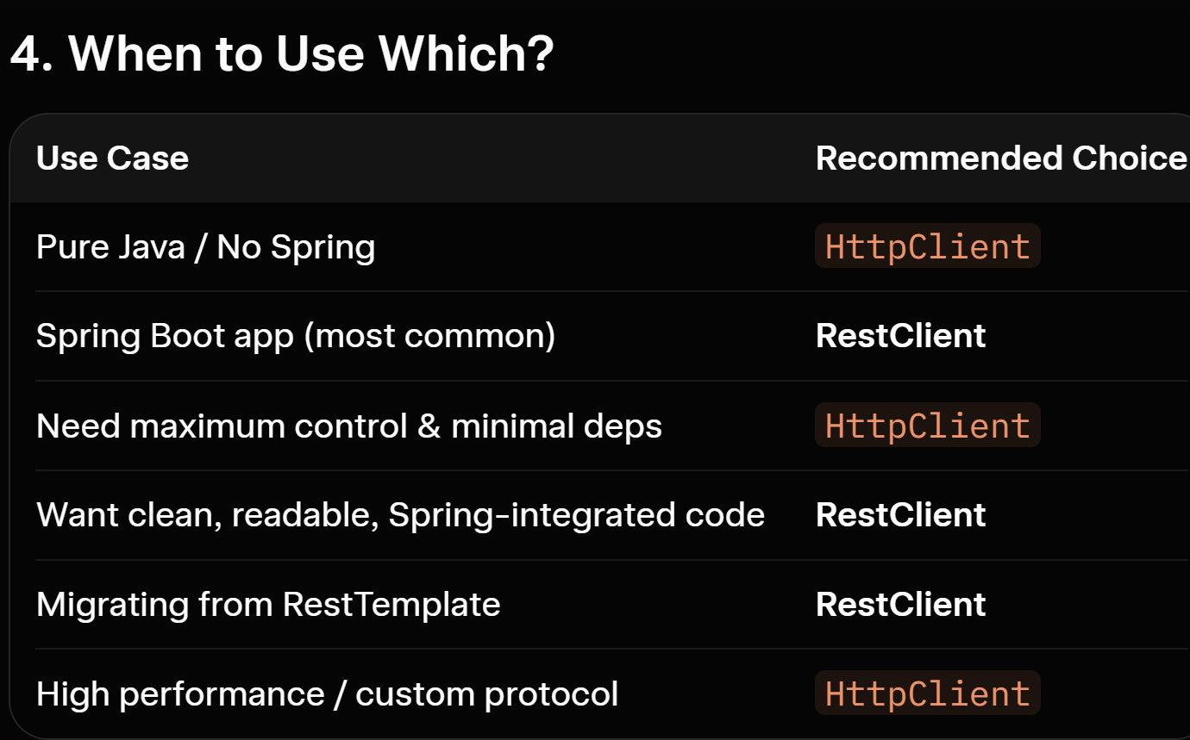
HttpClient = engine
RestClient = comfortable car built on top of the engine.

