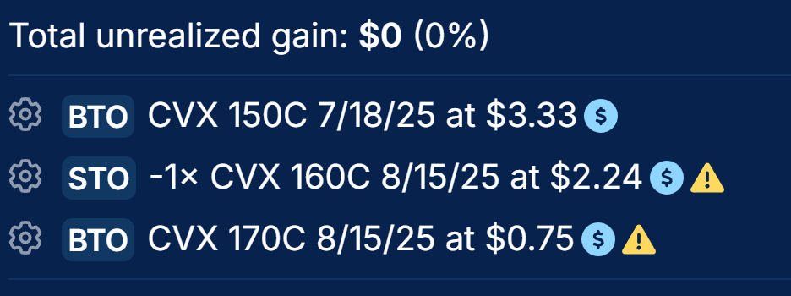

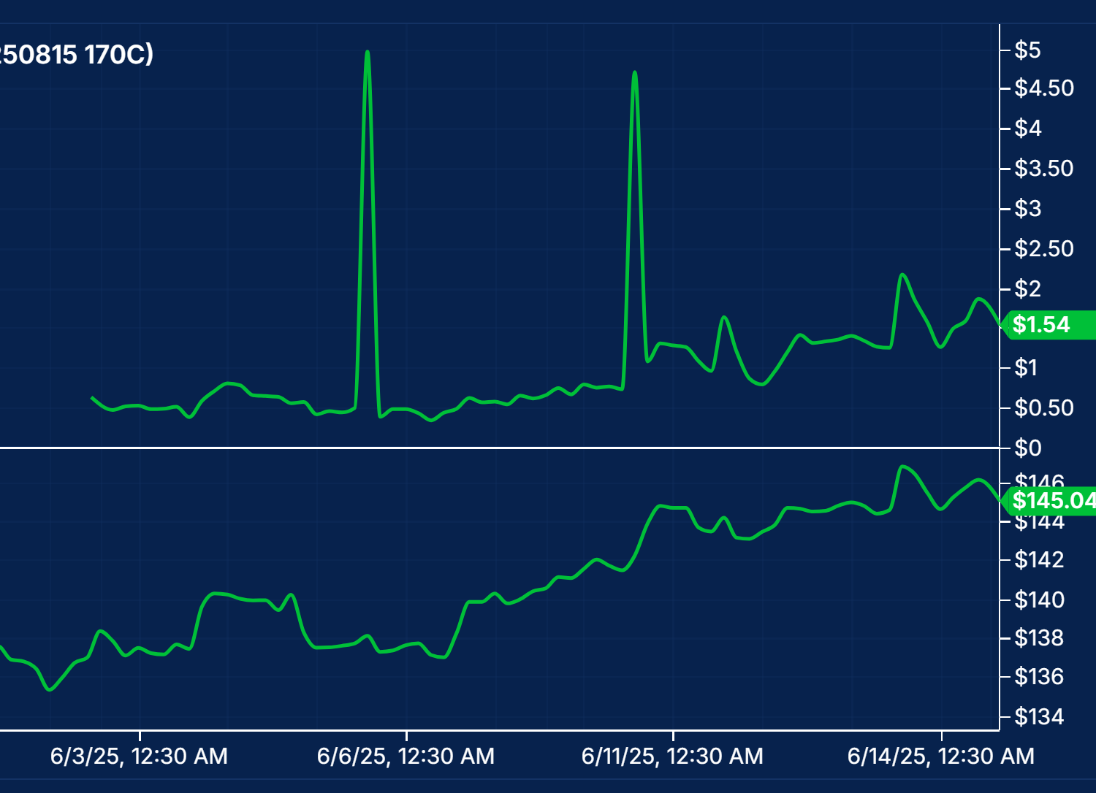

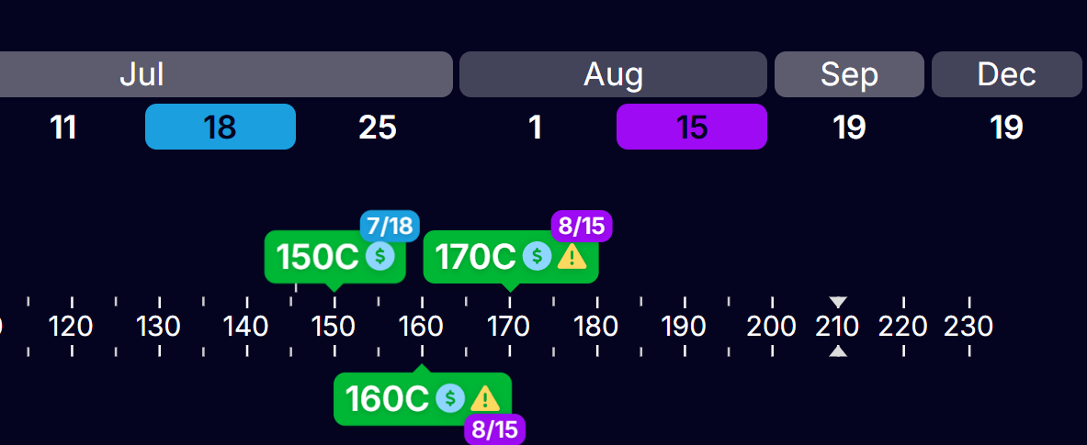

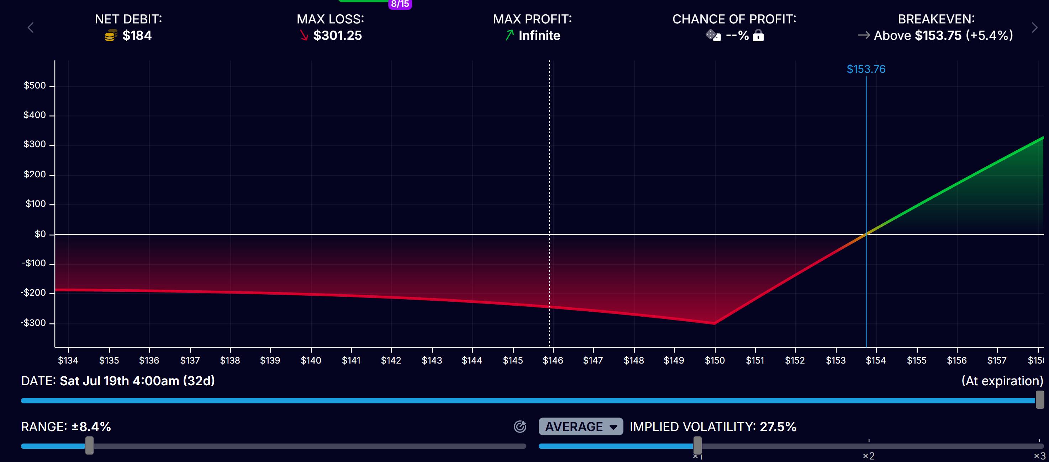

**Suggested Adjustments (If Needed)**

1. **If CVX Rises Quickly:**
   * Roll the short $160C up to a higher strike (e.g., $165 or $170).
2. **If CVX Stalls or Drops:**
   * Close the short $160C early to avoid assignment risk.
3. **For More Aggressive Upside:**
   * Skip the long $170C (just run a pure PMCC).