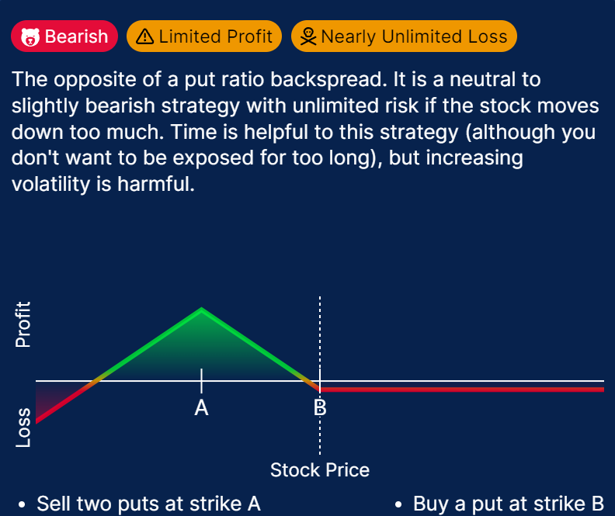



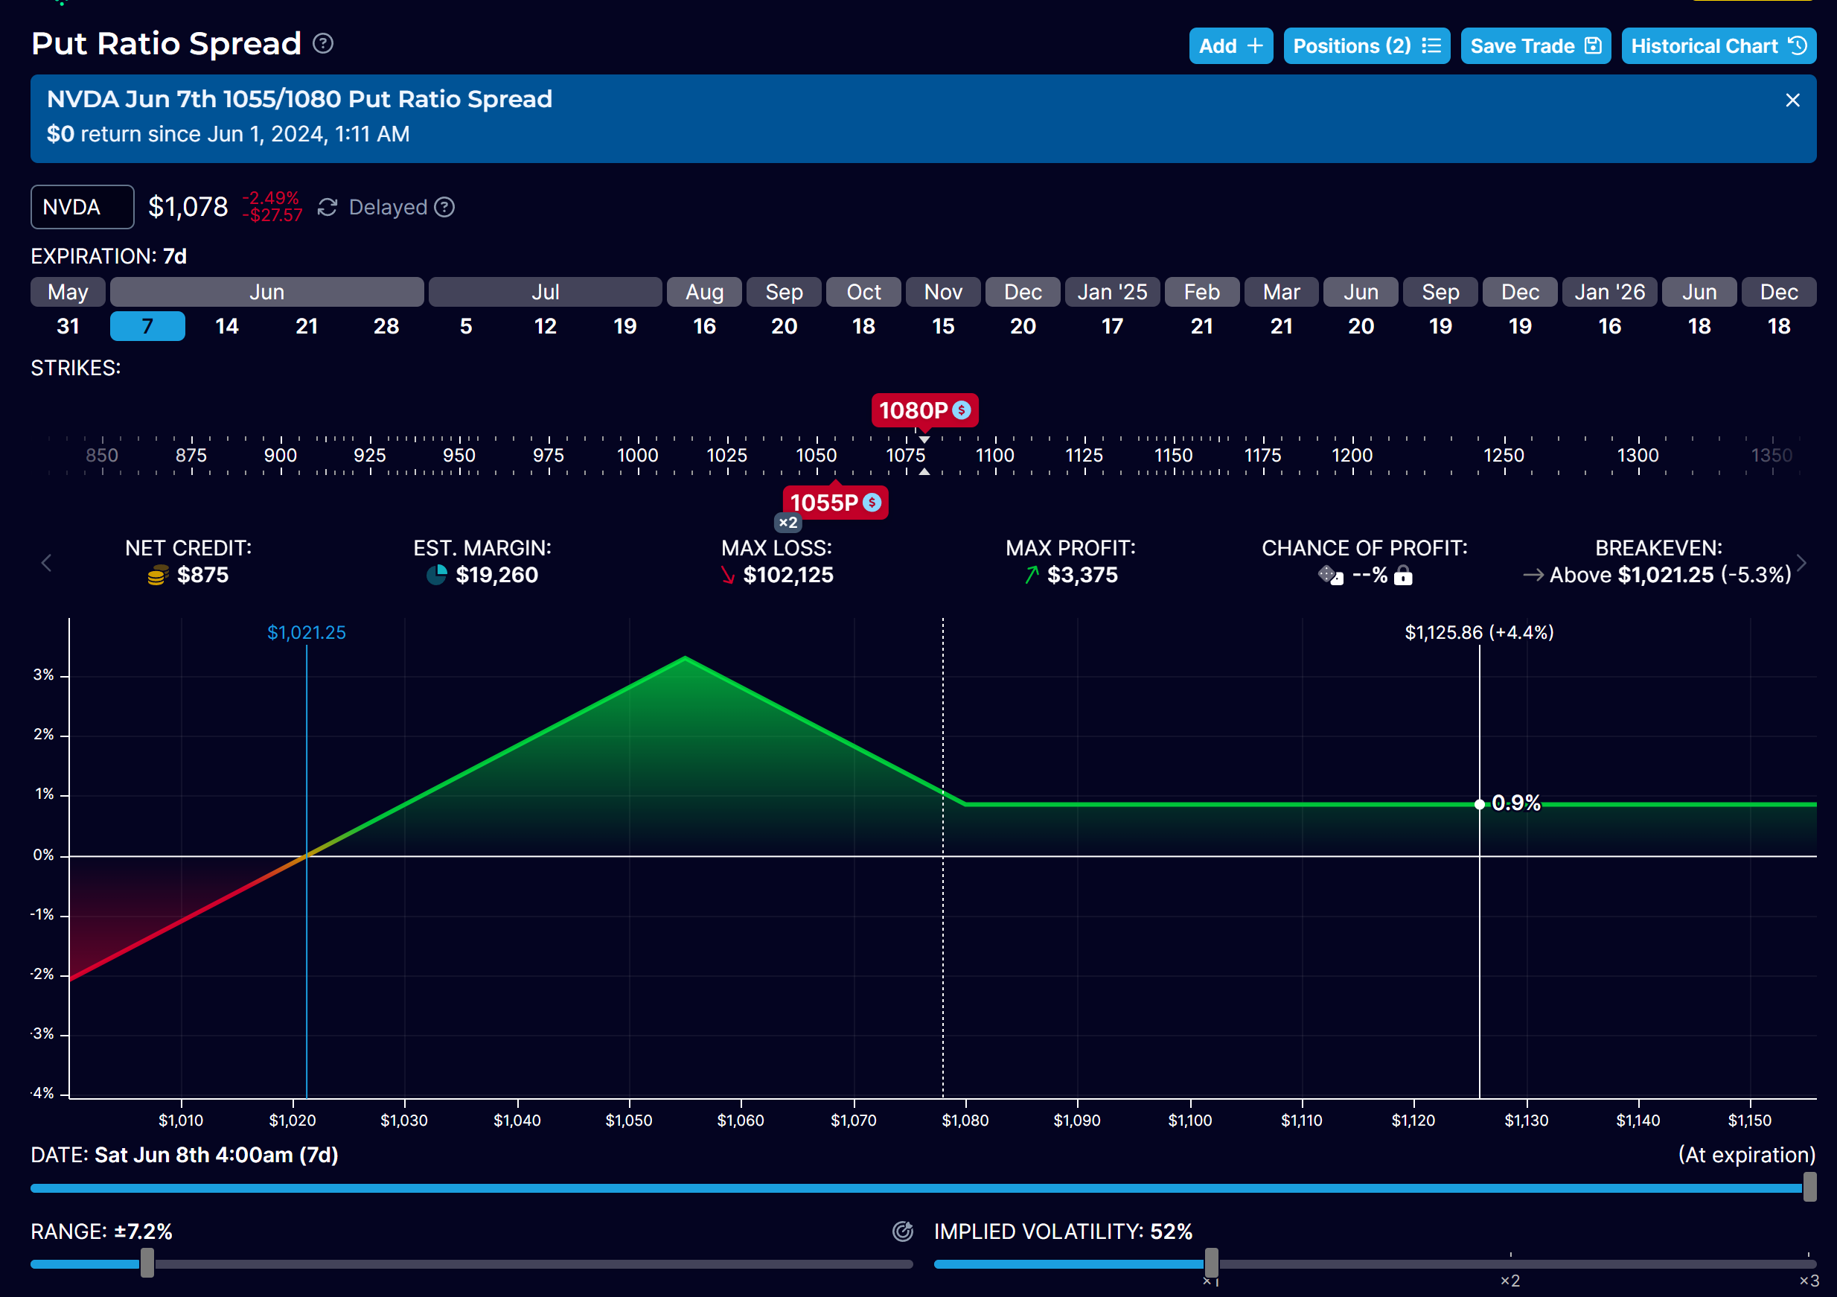

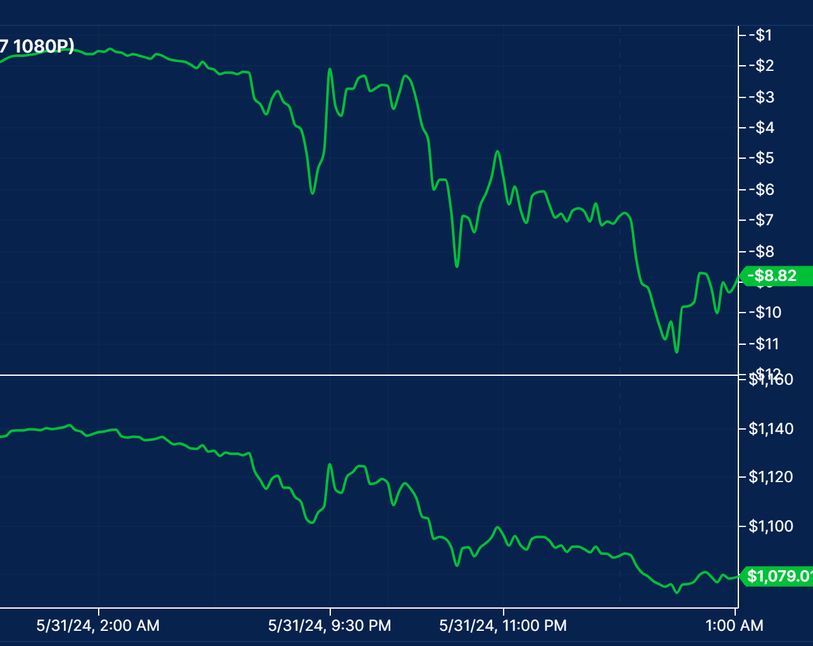

I must have exited this yesterday. No point in holding this any more.   
That is the functionality of Call Ratio. Get Quick profit and exit.  
But this require more investment since it need to sell 2 puts.  
I need to see the danger and % of the impact in opposite direction.

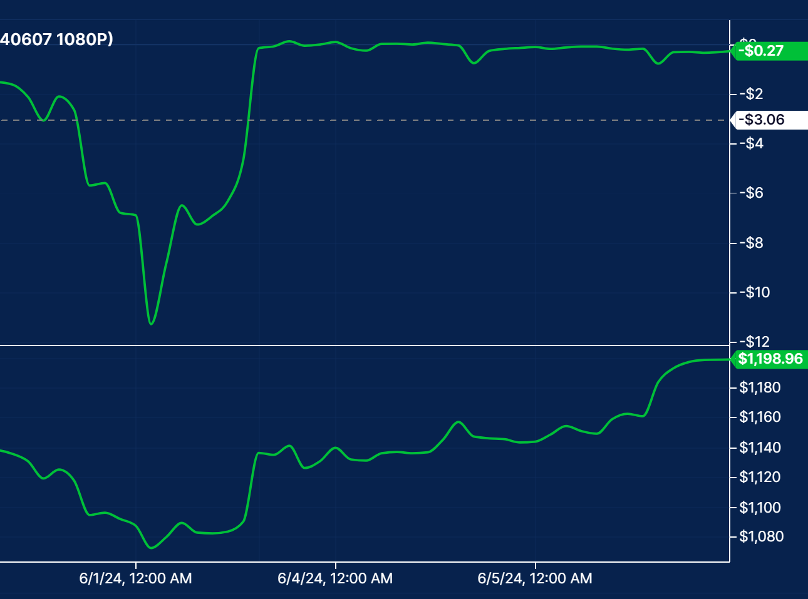

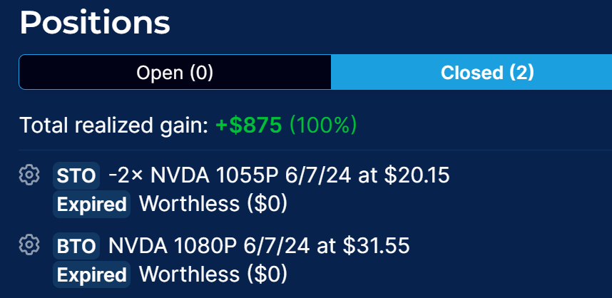

At the end, all the options will go to 0 and worthless

Net credit received $875 will be total profit at the end of the week

But it requires high investment of about $20000