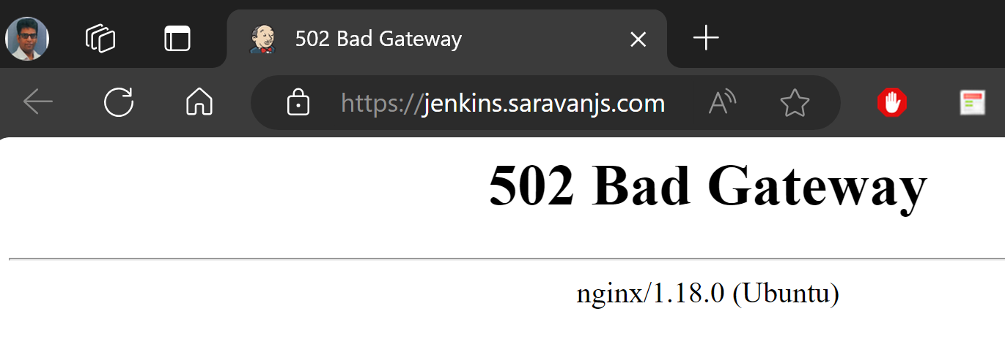

Feb 25 14:20:41 database jenkins[4700]: at executable.Main.main(Main.java:351)

Feb 25 14:20:41 database jenkins[4700]: 2024-02-25 14:20:41.348+0000 [id=1] WARNING winstone.Logger#logInternal: Failed to create dirs /var/cache/jenkins/war/META-INF

Feb 25 14:20:41 database jenkins[4700]: 2024-02-25 14:20:41.367+0000 [id=1] INFO winstone.Logger#logInternal: Jetty shutdown successfully

Feb 25 14:20:41 database jenkins[4700]: java.io.FileNotFoundException: /var/cache/jenkins/war/META-INF/MANIFEST.MF (Permission denied)

Feb 25 14:20:41 database jenkins[4700]: at java.base/java.io.FileOutputStream.open0(Native Method)

Solution : Remove that war folder

Jun 19 11:44:53 database jenkins[6522]: This may also be found at: /var/lib/jenkins/secrets/initialAdminPassword

Jun 19 11:44:53 database jenkins[6522]: *************************************************************

Jun 19 11:44:53 database jenkins[6522]: *************************************************************

Jun 19 11:44:53 database jenkins[6522]: *************************************************************

Jun 19 11:45:22 database jenkins[6522]: 2024-06-19 11:45:22.150+0000 [id=46] INFO jenkins.InitReactorRunner$1#onAttained: Completed initialization

Jun 19 11:45:22 database jenkins[6522]: 2024-06-19 11:45:22.414+0000 [id=39] INFO hudson.lifecycle.Lifecycle#onReady: **Jenkins is fully up and running**

Jun 19 11:45:22 database systemd[1]: **Started Jenkins Continuous Integration Server.**